Name ___________________________________ Block __________
PACKET #1

Unit 3: Body Systems – Part 1

Reading: Text chapters 4, 5, 22, 23, 25, 26, 28, 32
Objectives: Upon completion of this unit, you should be able to:
Topic 1: Gas Exchange (Chapter 22 and supplemental readings)
- Compare gas exchange in organisms in which all cells contact the environment with that in which most cells do not contact the environment. (22.2, 22.4)
- Describe the human respiratory system (including organs and functions). (22.6)
- Explain how the structure of alveoli enables them to be very efficient for gas exchange for a land dwelling organism (including the function of surfactant). (22.6)
- Describe negative pressure breathing. (22.8)
- Describe the effects of smoking on the respiratory system. (22.7)
- (Optional) Explain why cystic fibrosis is a disorder of the cell membrane system (supplemental reading).
Topic 2: Circulation (Chapter 23 and 32)
- Compare the differences in the circulatory systems of the classes of vertebrates, giving the advantages and disadvantages of each, including the drawing of each of the different types of hearts (23.2).
- Describe the structure of the 3 different types of blood vessels – arteries, veins, and capillaries (23.7).
- Label a drawing of the human heart and discuss the pattern of circulation (23.3, 23.5).

Unit 2 (The Dynamic Cell – Applications) Key Terms
Pharynx | Double circulation
Larynx | Atria
Trachea | Ventricles
Bronchus | Pulmonary artery
Bronchiole | Pulmonary vein
Lung | Aorta
Alveolus | Superior vena cava
Surfactant | Inferior vena cava
Cystic fibrosis | Septum
Diaphragm | Artery
Negative pressure breathing | Vein
CFTR protein | Capillary
Gas Exchange (Topic 1)
Preview thinking questions:

- Which has a higher O₂ concentration: your inhaled breath, or the blood arriving in the capillaries outside your lungs?
- Which has a higher CO₂ concentration: your inhaled breath, or the blood arriving in the capillaries outside your lungs?
- Why do molecules like O₂ and CO₂ travel across a cell membrane? What drives them to travel? Are they pumped? Explain.
- When you exhale, are there any O₂ molecules in your exhaled breath? Explain.
- What do you think is the most prevalent molecule in your inhaled AND exhaled breaths?

Objective 1: Compare gas exchange in organisms in which all cells contact the environment with that in which most cells do not contact the environment. (22.2, 22.4)
______________________________________________________________________________________
______________________________________________________________________________________
______________________________________________________________________________________
______________________________________________________________________________________
______________________________________________________________________________________
_____________________________________________________________________________________
______________________________________________________________________________________
Objective 2: Describe the human respiratory system (including organs and functions). (22.6)
______________________________________________________________________________________
______________________________________________________________________________________
______________________________________________________________________________________
______________________________________________________________________________________
______________________________________________________________________________________
______________________________________________________________________________________
______________________________________________________________________________________
_label diagram on next page!________________________________________________________________
Objective 2: Describe the human respiratory system (including organs and
functions). (22.6)
G
A
B
C
D
E
F
H (air sacs)
I
J
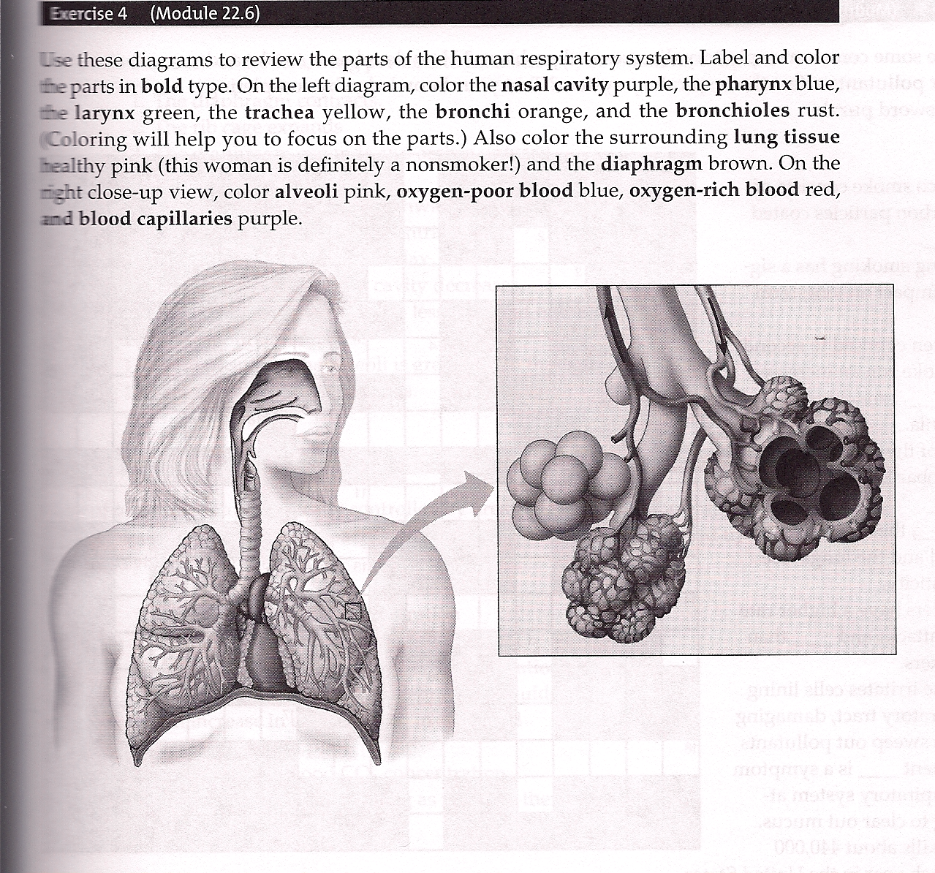
H
K (blood vessels)

A _______________ D _______________ G _______________ J _______________
B _______________ E _______________ H _______________ K _______________
C _______________ F _______________ I _______________

H
G
K (blood vessels)
Objective 3: Explain how the structure of alveoli enables them to be very efficient for gas exchange for a land dwelling organism (including the function of surfactant). (22.6)
______________________________________________________________________________________
______________________________________________________________________________________
______________________________________________________________________________________
______________________________________________________________________________________
______________________________________________________________________________________
______________________________________________________________________________________
______________________________________________________________________________________
______________________________________________________________________________________
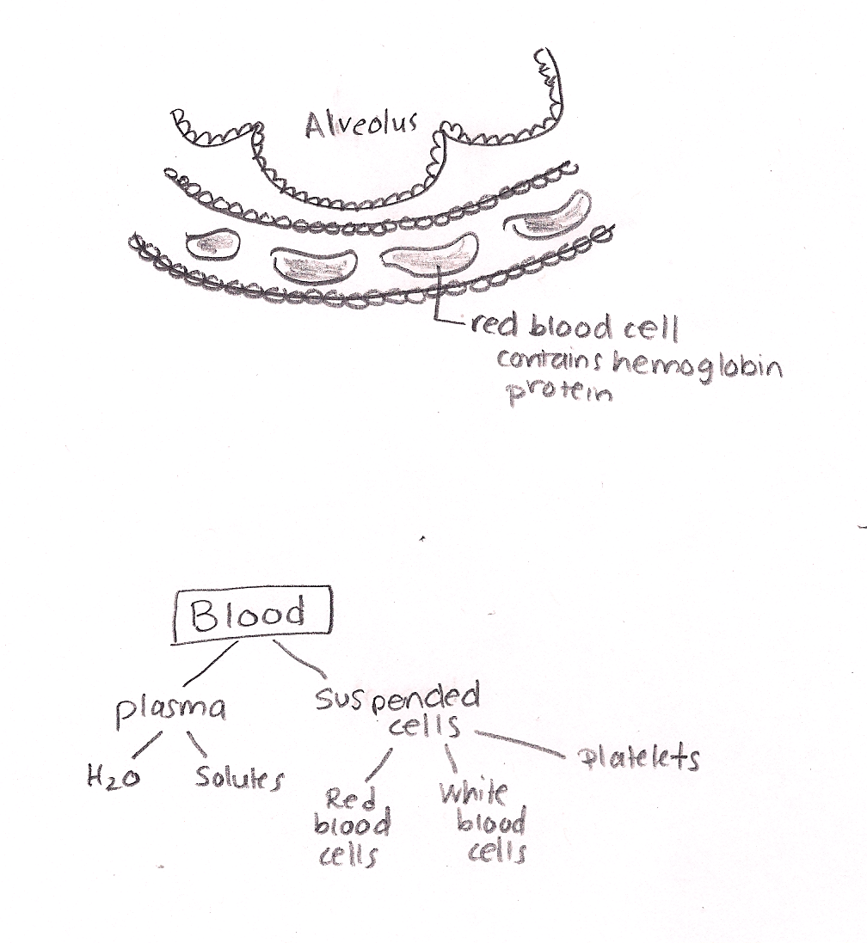

Objective 4: Describe negative pressure breathing. (22.8)
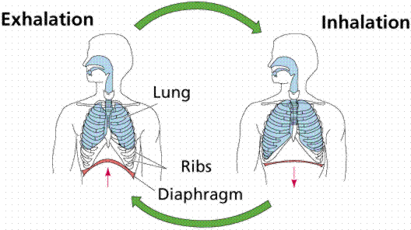
_____________________________________
_____________________________________
_____________________________________
_____________________________________
_____________________________________
_____________________________________
_____________________________________
_____________________________________
_____________________________________
_______________________________________________________________________________________
_______________________________________________________________________________________
Objective 5: Describe the effects of smoking on the respiratory system. (22.7)
______________________________________________________________________________________
______________________________________________________________________________________
______________________________________________________________________________________
______________________________________________________________________________________
______________________________________________________________________________________
______________________________________________________________________________________
______________________________________________________________________________________
______________________________________________________________________________________
______________________________________________________________________________________
______________________________________________________________________________________
______________________________________________________________________________________
_______ ______________________________________________________________________________
______________________________________________________________________________________

Objective 6: Explain why cystic fibrosis is a disorder of the cell membrane system (supplemental reading).
______________________________________________________________________________________
Drawing: (in class)
______________________________________________________________________________________
______________________________________________________________________________________
______________________________________________________________________________________
______________________________________________________________________________________
______________________________________________________________________________________
______________________________________________________________________________________
______________________________________________________________________________________
______________________________________________________________________________________
______________________________________________________________________________________
______________________________________________________________________________________
______________________________________________________________________________________
______________________________________________________________________________
______________________________________________________________________________________
Respiration Practice Questions:

- Over the course of this year, we have often discussed the relationship between form and function. Here in this unit, we see yet another - this time again with surface area. Discuss the relationship between the form/surface area of the lung and the function of the lung. A good way to discuss this relationship would be to say something like: “If the lung didn’t have as much surface area…”
- How does the epiglottis prevent choking?
- Suppose that you were a carbon atom that’s part of a CO₂ molecule. Beginning at a capillary (blood vessel) just outside the lung, narrate your journey from the bloodstream to the outside air. Be specific – name all structures you would pass through (pharynx, larynx, bronchi, trachea, alveolus, etc – but not in that order…), and discuss what part of the membrane you would use to travel from the bloodstream to the lung.

- On a conceptual level, explain why volume and pressure are inversely related.
- Describe four negative effects that smoking has on a person’s body (be specific!):

- Carriers of the mutated cystic fibrosis gene have a natural resistance to cholera (a disease that causes watery diarrhea and ultimately, death by dehydration). Using the concepts we discussed in class, explain why carriers have the benefit. (Make sure you mention the CFTR protein and what the normal, nonmutated version does for a person).

Circulation (Topic 2)
Preview thinking questions:

- What would happen to your blood cells (white blood cells and red blood cells, for example) if your blood plasma had an abnormally high concentration of solutes? In other words, what would happen if your blood plasma were hypertonic, as compared to the cytoplasm of your blood cells? Explain.
- What would happen to your blood cells if your blood plasma were pure water? In other words, what would happen if your blood plasma were hypotonic, as compared to the cytoplasm of your blood cells? Explain.

Objective 7: Compare the differences in the circulatory systems of the classes of vertebrates, giving the advantages and disadvantages of each, including the drawing of each of the different types of hearts (23.2).
______________________________________________________________________________________
______________________________________________________________________________________
______________________________________________________________________________________
______________________________________________________________________________________
______________________________________________________________________________________
______________________________________________________________________________________
______________________________________________________________________________________
______________________________________________________________________________________
______________________________________________________________________________________
______________________________________________________________________________________
Objective 8: Describe the structure of the 3 different types of blood vessels – arteries, veins, and capillaries (23.7). ________________________________________________________________________________
______________________________________________________________________________________
______________________________________________________________________________________
______________________________________________________________________________________
______________________________________________________________________________________
______________________________________________________________________________________
______________________________________________________________________________________
______________________________________________________________________________________
______________________________________________________________________________________
Objective 9: Label a drawing of the human heart and discuss the pattern of circulation (23.3, 23.5).

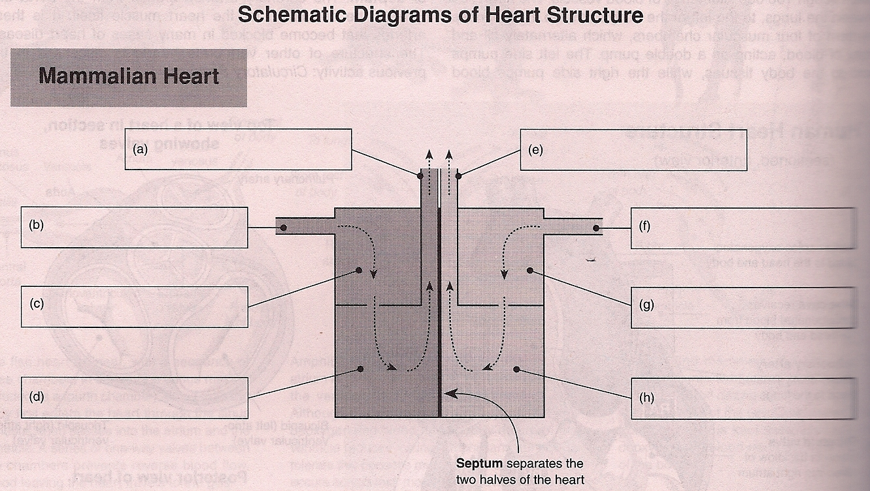
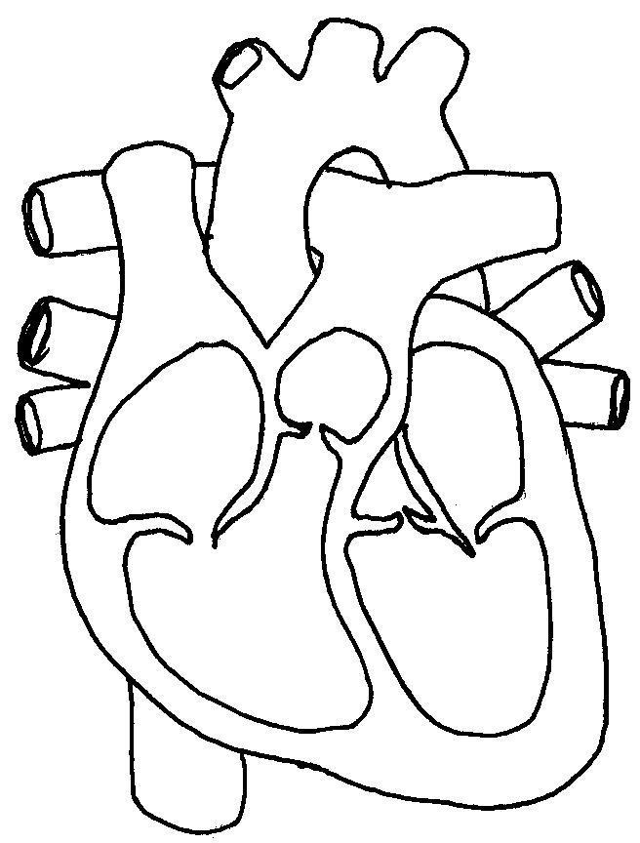
1
2
3
4
5
5
6
6
7
8
9

Color Code:
RED = O₂-rich/CO₂-poor
BLUE = O₂-poor/CO₂-rich

Objective 9, cont’d: Label a drawing of the human heart and discuss the pattern of circulation (23.3, 23.5).
______________________________________________________________________________________
______________________________________________________________________________________
______________________________________________________________________________________
______________________________________________________________________________________
______________________________________________________________________________________
______________________________________________________________________________________
______________________________________________________________________________________
______________________________________________________________________________________
______________________________________________________________________________________
______________________________________________________________________________________

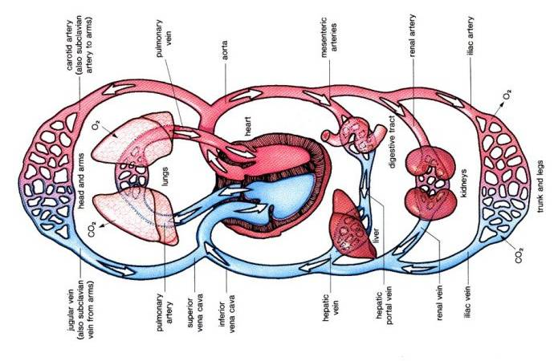

Color Code:
RED = O₂-rich/CO₂-poor
BLUE = O₂-poor/CO₂-rich
Note: The diagram above mistakedly indicates that a single pulmonary artery goes toward both the right AND left lungs. In actuality, the pulmonary artery splits into a right pulmonary artery and a left pulmonary artery. The same is true of the pulmonary vein. This is shown on the diagram on the next page.

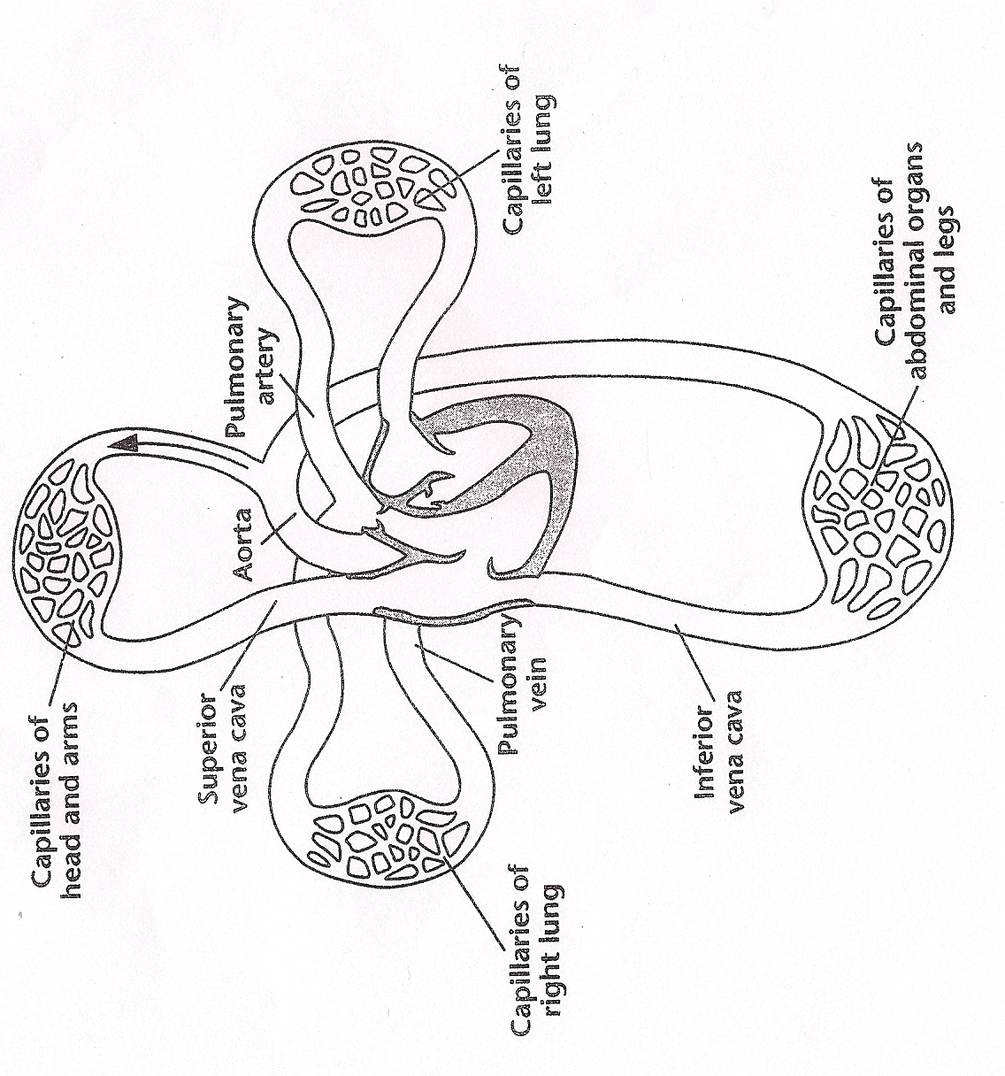

Directions for Diagram:
1. Starting with the right atrium, draw arrows to show the direction of blood flow.
2. Color code, with red as O₂-rich/CO₂ -poor and blue as O₂-poor and CO₂-rich
3. Label each of the following: right pulmonary artery, left pulmonary artery, right pulmonary vein, left pulmonary vein
4. True or false? Only the left pulmonary vein (not the right pulmonary vein) goes to the left atrium. ________

Circulation Practice Questions
- When comparing the two types of closed circulatory systems, explain why a double circuit is more efficient than a single circuit.

- Complete the following chart:
Chamber or Vessel name | O₂-rich or O₂-poor blood?
Left Ventricle
Right Ventricle
Left Atrium
Right Atrium
Pulmonary Artery
Pulmonary Vein
Superior Vena Cava
Inferior Vena Cava
Aorta
Renal Artery
Renal Vein
Hepatic Vein

- Identify the part or parts of the circulatory system described by each phrase:
  - Made of cardiac muscle: __________________
  - The upper chambers of the heart: __________________
  - Carry blood toward the heart: ___________________
  - Located between the upper and lower chambers of the heart, these structures prevent blood from flowing backward through the heart: __________________
  - Lower chambers of the heart: ______________________
  - Thin-walled blood vessels through which materials diffuse into and out of individual cells: _________________________
  - Type of blood vessels that carry blood away from the heart: ____________________
- In what type of vessel (artery, arteriole, capillary, venule, vein) is blood at its highest velocity? _______ lowest velocity? _________
- In what type of vessel is blood at its highest pressure? ________ lowest pressure? ________
- Explain how your answer to the previous question relates to diffusion of gasses (O₂ and CO₂).
- Suppose that you were a red blood cell starting at the right atrium. List the chambers and vessels you would experience before returning back to the right atrium.
- Referencing your answer to #7, how many capillary beds would you pass through before you came back to the right atrium? (assume that you ended up in the renal artery at some point)
- What is the body’s only artery that carries O₂-poor blood?
- Why is it advantageous for O₂-rich blood to return to the heart, before the O₂-rich blood goes out to the rest of the body?
- When blood leaves the right side of the heart, it goes to the _________________.
- When blood leaves the left side of the heart, it goes to the __________________.
- Which of the human heart’s four chambers is the most muscular? ________________. Explain why it is so important that this chamber be so muscular

