BSCS Packet #6 – Cells - Internal Environment, part 1 (Unit 4) 2013-2014

This Activity Packet belongs to: __________________________ (Block _____)

Use this packet for your classwork, class notes and homework. Work completed in the packet will be stamped (3 pts) or could be the topic of a mini-quiz (5-8 pts). Mini quizzes will occur approximately once a week and will not be announced. At the end of this learning cycle you will turn in the packet for a grade (10 pts). Several of the packet activities have sections that need to be completed on separate sheets of paper, these sections are clearly marked with a box.
.

5E Model | Packet page | Activity | Due Date for Completion
Engage | 1-3 | Journal 4-1: Can you stand the heat?
Explore | 4 | Lab 4-1: Egg Osmosis Demo
 | 5-6 | Journal 4-2: Diffusion Demonstrations
 | 7-8 | Journal 4-3: Bubble Membranes
Explain | 9-10 | Notes: Transport and Diffusion
 | 11-14 | Diffusion Practice Problem Set
Elaborate | 15-17 | Lab 4-2: Cell Size and Diffusion (Agar Cubes)
Evaluate | 18 | Unit 4 Review Guide for Part 1

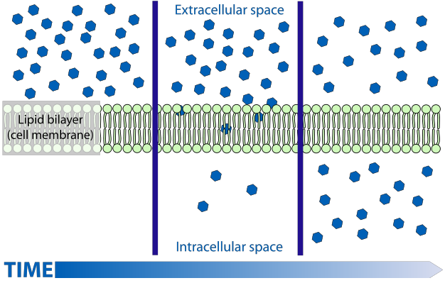

If this packet is LOST, please:
drop it off at the BHS Science Dept. (rm 365) OR
drop it off in Mr. Kozel’s classroom (360) OR
call the Science Dept. at (617) 713-5365.

Journal 4-1: Can you stand the heat? - Introduction to Unit 4: Internal Environment – Cells and diffusion
Unit 4: Internal Environment

Maintaining a Balance

Digestive system (Review)

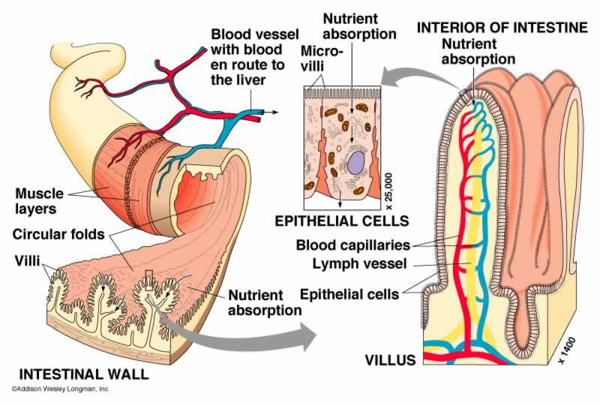

Absorption the Small Intestine (Review + a little more)

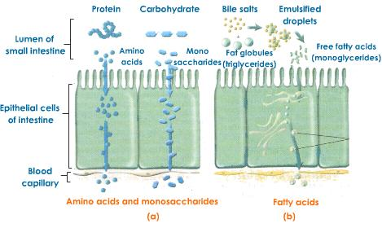

Process and Procedures

1. Read the following story then answer the questions that follow.

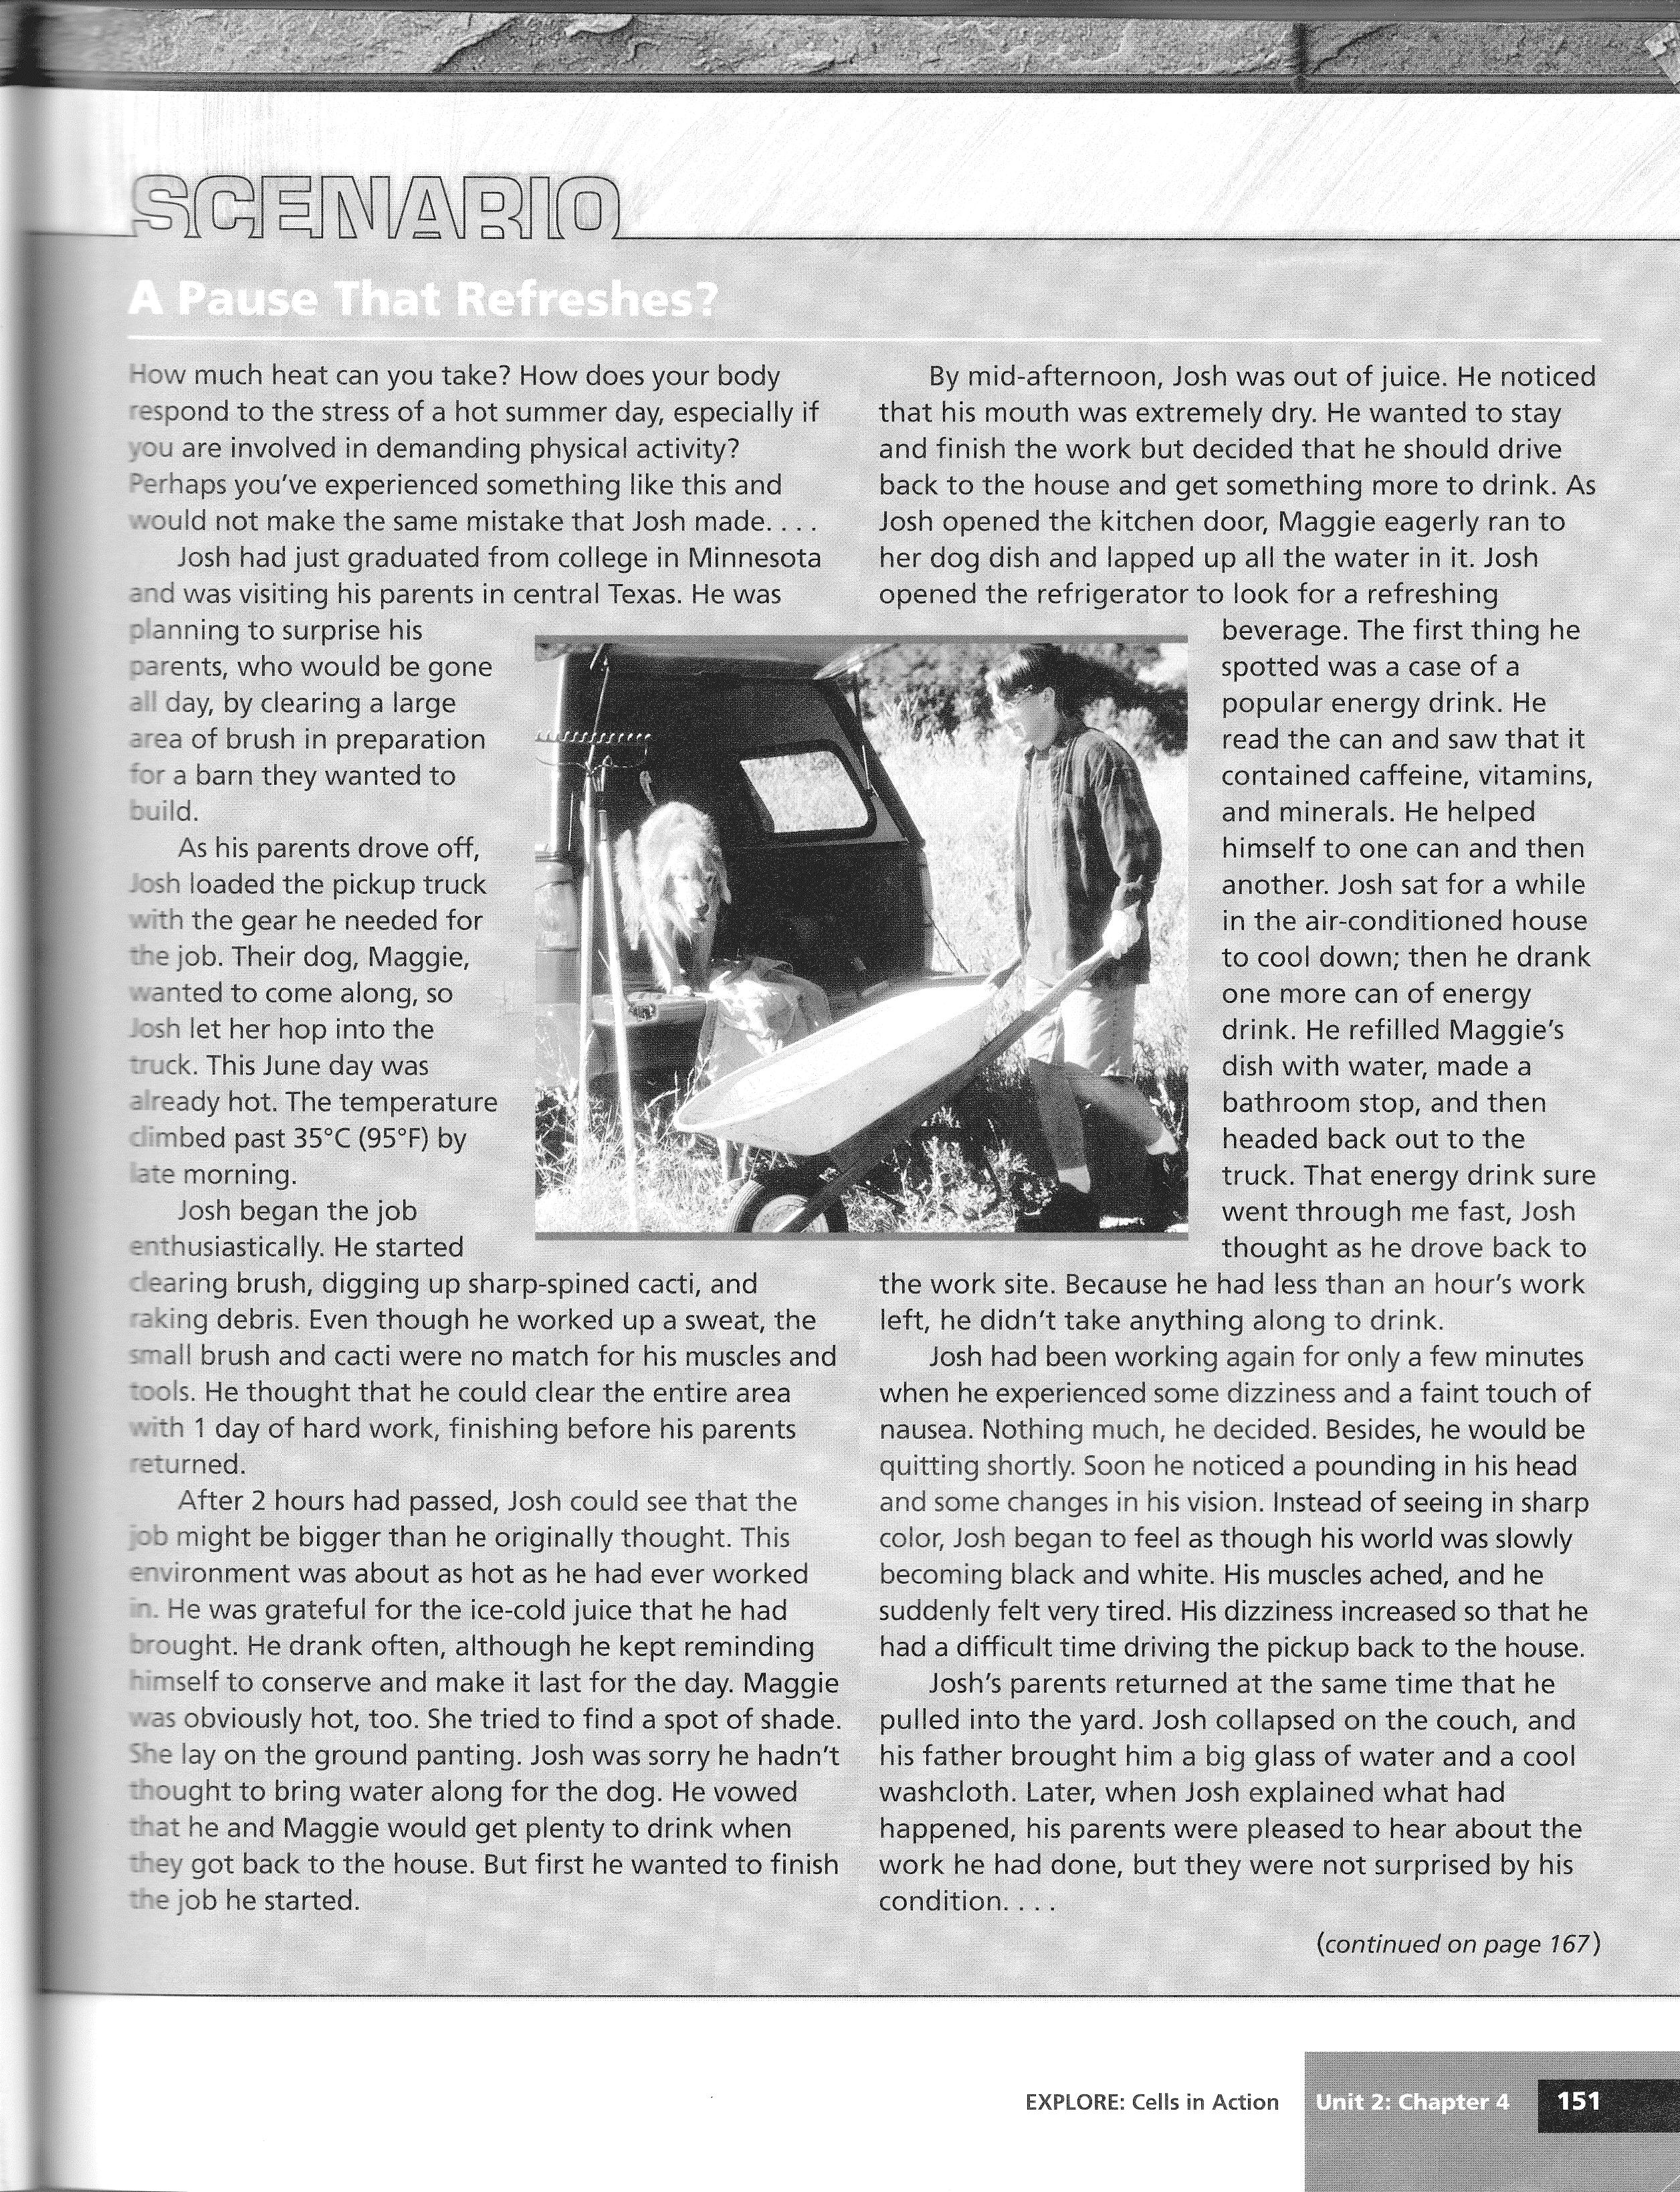
- After reading the scenario, work with your partner to develop an explanation for Josh’s condition. Consider the evidence you have and what inferences you can make about how Josh’s body responded to external stress.

- What stresses from the external environment was Josh’s body (internal environment) having to balance?

- How did the choices Josh made affect the stresses placed on his body?

- What symptoms did Maggie show that were evidence that her body (her internal environment) was under stress from the conditions outdoors (her external environment)?

- Develop a list of four terms and concepts that relate to homeostasis.

Unit 4 Reading Guide
Chapter 7 Cell Structure and Function
I. Cell Boundaries (Section 7-3, p. 182)
A. Cell Membrane
i. What is the function of the cell membrane?

ii. What is the primary component of the cell membrane? How is it arranged?

iii. Name two other organic macromolecules that are found in cell membranes. What are their general functions?

iv. Describe why the cell membrane is called a ‘fluid mosaic ‘ model.

B. Cell Walls
i. What kinds of organisms have cell walls?

ii. What is the main function of the cell wall?

iii. What are the two macromolecules that make up cell walls?

Lab 4-1: Egg Osmosis Demo

Background Information:
Osmosis is the diffusion of water across a selectively permeable membrane. This means that water can go through membranes from areas where there are a lot of water molecules to areas where there are not so many water molecules.

To perform their functions, cells must keep an internal steady state even when the environment outside of the cell is changing. This steady state is called homeostasis. Homeostasis is maintained in part by controlling the movement of materials into and out of the cell. To achieve this control, a membrane that can tell different substances apart surrounds cells. This membrane can slow down or stop the movement of some substances while allowing others to pass through freely. Because not all substances can go through the cell membrane equally well, the membrane is said to be selectively permeable. Selectively permeable membranes are those that have openings called pores that let water, oxygen, carbon dioxide and certain other small molecules go through the membrane.

Cells in the human body need a constant supply of oxygen and water. They also make carbon dioxide as a waste, which needs to be removed from the cell. These substances can move into and out of a selectively permeable membrane around a cell through the process of osmosis.

Materials: 3 raw eggs (shells removed with vinegar), 3 beakers, distilled water, karo corn syrup, .8% saline solution

Data:

Egg | Solution | Starting mass (g) | Ending mass (g) | % Change in mass | Observations
A | Distilled H₂O | 91.20 | 93.64 | 2.0%
 |  | 91.24 | 94.12 | 3.2%
B | 20 % sucrose | 89.34 | 88.25 | -1.2%
 |  | 87.00 | 85.96 | -1.9%
C | Vinegar | 90.30 | 93.06 | 3.1%
 |  | 96.90 | 100.40 | 3.6%

Questions and Conclusions – Complete on a Separate sheet of paper
1. When the egg was placed in each of the following substances, which direction did the water move? Explain using data how you know this.
a. Distilled water
b. Corn syrup
c. 0.8% Saline Solution
2. Formulate an explanation (involving osmosis) for each of the following scenarios:
a. Grocery stores spray fresh produce with water.
b. If a shipwrecked crew drinks salt water, they will actually dehydrate and die.
c. If a bowl of fresh strawberries is sprinkled with sugar, a few minutes later they will be covered in juice.
3. Pick one of the eggs and draw a diagram of the experiment. Use arrows to show the direction of water movement.

Journal 4-2: Diffusion Demonstrations
Purpose:
In this activity you will observe the diffusion of a substance across a semi-permeable membrane. Iodine is a known indicator for starch. An indicator is a substance that changes color in the presence of the substance it indicates. Watch as your teacher demonstrates how iodine changes in the presence of starch.
Materials: Iodine, cornstarch/water solution, plastic dialysis tubing, beaker
Set-Up and Procedure
- Fill beaker about halfway with water and put about ten drops of iodine.
- Put about 25 ml of a starch solution in dialysis tubing and tie closed. Make sure that it is watertight.
- Put the baggie in the beaker and wait about 15 minutes before making observations. While you are waiting answer the following questions.
Questions:
- What happened when iodine came in contact with starch?
- Why is iodine called an indicator?
- Molecules tend to move from areas of (high / low) concentration to areas of (high / low) concentration.

- Is the bag or beaker more concentrated in starch?

- Is the bag or beaker more concentrated in iodine?

- If the bag were permeable to starch (allowed starch to move through it), which way would the starch move – into or out of the bag (Remember – molecules move from high concentration to low concentration)?

- If the bag were permeable to iodine, which way would the iodine move – into or out of the bag?

- If the bag were permeable to iodine, what color would you expect the solution in the baggie to turn? __________________ What about the solution in the beaker? __________________

- If the bag were permeable to starch, what color would you expect the solution in the baggie to turn? __________________ What about the solution in the beaker? __________________

- Make a prediction about what you think will happen: (record you observations only after completing this step)

Observations
 | Starting Color | Ending Color
Baggie (starch/water)
Beaker (Iodine/water)

Analysis Questions – Complete on a separate sheet of paper
1. Define permeability
2. To which substances is the plastic bag permeable? How did you determine this?
3. Why did the iodine enter the bag?
4. Why didn’t the starch enter the beaker?
5. How is the plastic bag like the cell membrane?
6. Sketch the beaker and bag. Use arrows to illustrate how diffusion occurred in this lab.
7. (Honor). Can we determine if water entered the bag? What types of observations would allow us to draw this conclusion?

Reading Guide
Chapter 7 Cell Structure and Function
II. Cell Boundaries part 2(Section 7-3, p. 182)
C. Diffusion
i. Why do substances diffuse? Use the words random movement and concentration in your answer.

ii. Give a formal definition of diffusion.

iii. Once particles reach equilibrium, do they stop moving across a membrane? Explain.

D. Osmosis
i. What does semi-permeable or selectively permeable mean? Why is it important for cells to be semi-permable?

ii. Define Osmosis:

iii. Read How Osmosis Works and use Figure 7-15 to explain what hypertonic, isotonic, and hypotonic mean. Make sure you describe which direction WATER moves in each type of solution.

iv. Use Figure 7-16 to explain the differences between plant and animal cells in isotonic, hypertonic, and hypotonic solutions. For example, what happens to a plant cell in a hypotonic solution and why? What happens to an animal cell in a hypotonic solution, and why?

Journal 4-3: Bubble Membranes

Intro: Soap bubbles are bilayers very similar to cell membrane bilayers, so they can be used to display some of the properties of the cell membrane.
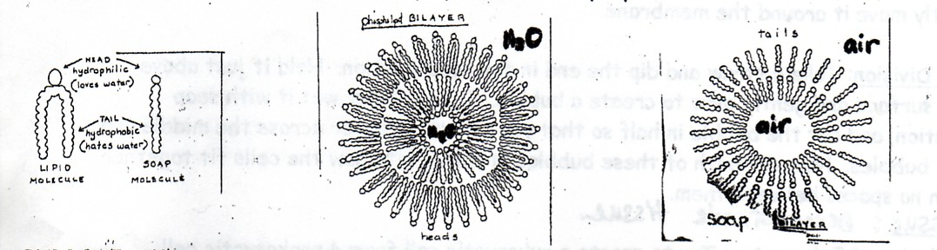
Purpose: What are the characteristics of a cell membrane?

Procedure:
Immerse the membrane holder into the pan of soap solution. Demonstrate the following characteristics of a lipid bilayer and RECORD ALL OBSERVATIONS in the table below.

Observations
Fluidity: Form a layer in the membrane holder. Let the light shine off of its surface and look at the movement you see within the film.
Flexibility: Twist the two straws in opposite directions, and bend it into different types of configurations.
Self-sealing: Stick the following objects through the bubble membrane and observe what happens when you try to remove them as well:
a. Wooden flint stick
b. Soap-coated flint stick
c. Your finger
d. Your soap-coated finger

Transport proteins: Form a film in your membrane holder. Dip the thread (or elastic band) in the soap solution and carefully place it onto the membrane. The thread should float in the membrane. Pop the inside of the circle. Stick your dry finger (or another dry object, like your pencil) through the pore created by the circular thread and gently move it around the membrane. Try to carefully remove the thread from the membrane and see if the membrane is able to self-seal.

Analysis Questions – Complete on a separate sheet of paper
- Describe what you observed about the bubble membrane’s “fluidity” and explain how this relates to the structure of the cell membrane.
- What are the three major components of the cell membrane and how are they organized (refer to Journal 4-2 and the reading you did for some help with this question)?
- Explain how the “self-sealing” bubble membrane helps to illustrate the passage of molecules through a cell membrane and the property of selective permeability.
- What happened when you placed a circular thread into the bubble film? Explain why this thread represents a transport protein and describe how transport proteins work.
- Explain how selective permeability maintains homeostasis within a cell.

Reading Guide
Chapter 7 Cell Structure and Function
III. Cell Boundaries part 3 (Section 7-3, p. 182)
E. Facilitated Diffusion
i. What is facilitated diffusion? Does it require energy?

ii. What kinds of molecules use facilitated diffusion?

F. Active Transport
i. Define active transport:

ii. Molecular Transport: how are ions moved across the membrane?

iii. Honors: Define Endocytosis and distinguish between phagocytosis and pinocytosis.

iv. Honors: Define Exocytosis.

Notes: Membranes and Diffusion

Cell Membrane Structure

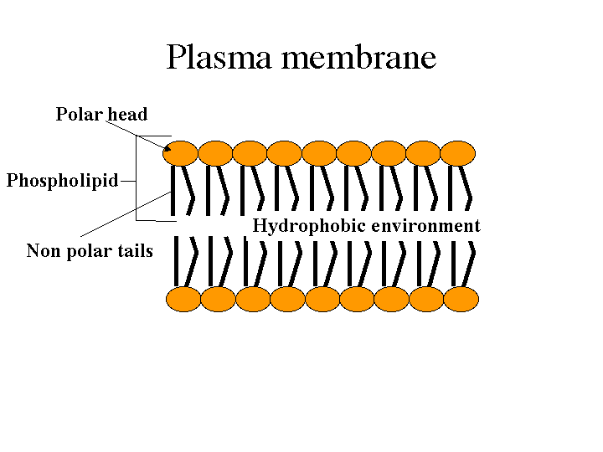

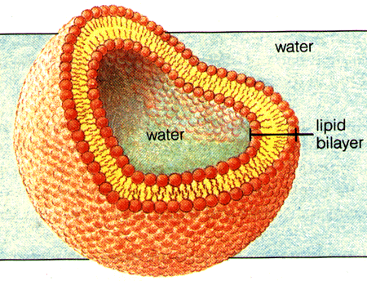
Cell Membrane Function
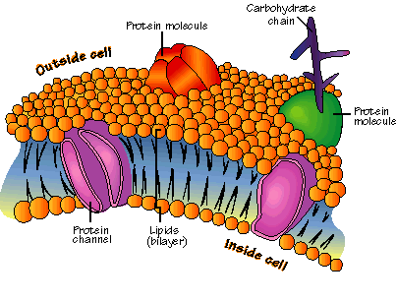
(What does each component do?)

The Problem: Imagine the plastic bag is a cell and the candy is the food. You must get the candy into the bag, using the following rules:
- The candy must enter through a solid part of the bag
- The inside of the bag may not be directly open to the external environment
- The candies entering the bag must remain clustered together
- You may work with your hands inside the bag to act as the inside of the cell
- The candy may only be eaten if it enters the bag “cell” under these conditions

Describe your final solution:

What is diffusion

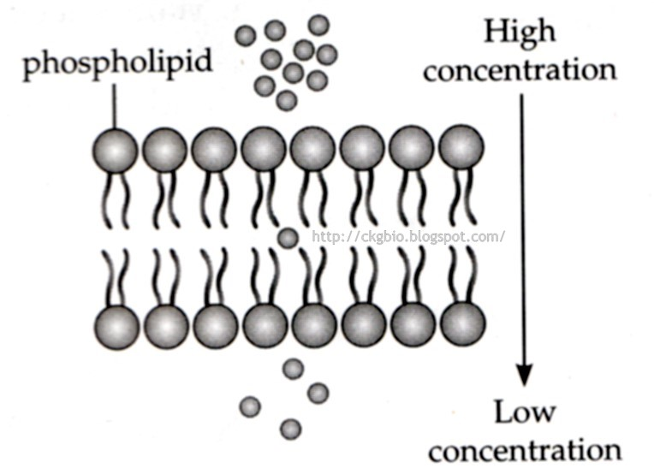
Types of diffusion

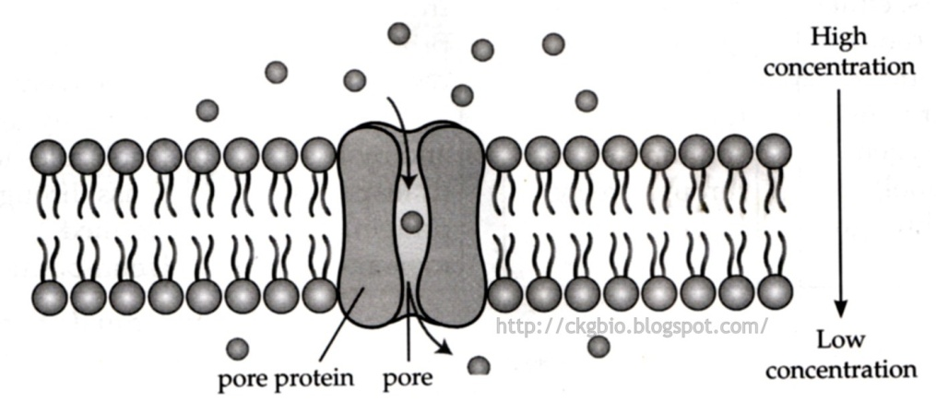

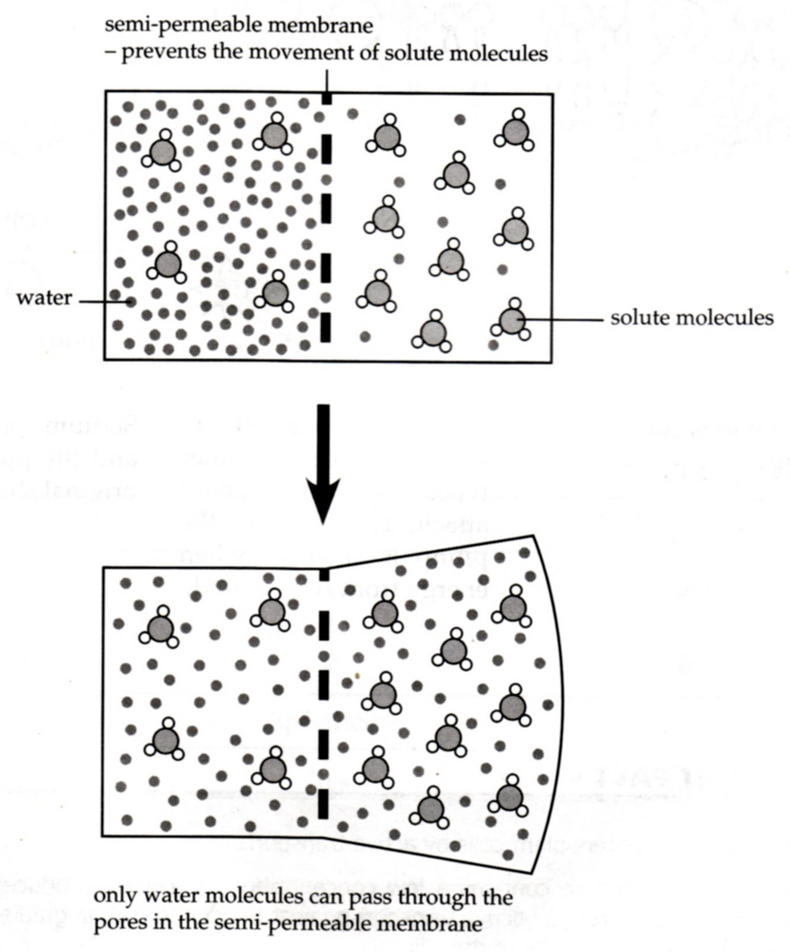
Osmosis

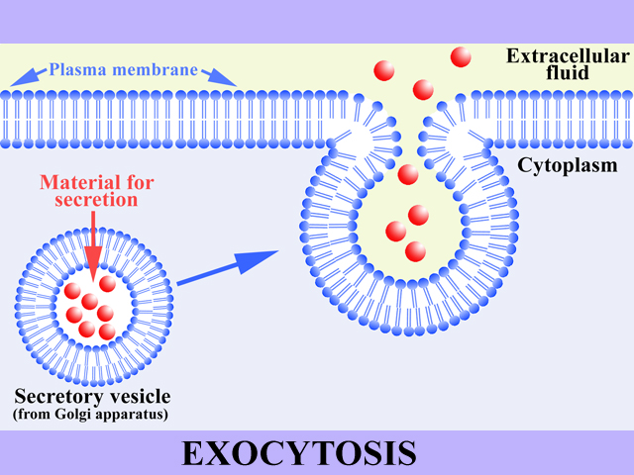
Active Transport

Diffusion Practice Problem Set – Complete the following in this packet – see the weekly planner for due dates

- The best definition of Homeostasis is:
  - Keeping a constant temperature inside a cell or organism despite external changes.
  - Keeping constant conditions within a cell or organism despite external changes.
  - Keeping a constant pH inside a cell or organism despite external changes.
  - Keeping constant conditions outside a cell or organism despite internal changes.

- The three most abundant molecules in the plasma membrane are:

- This is true of the structure of the plasma membrane:
  - It is a double layer of protein molecules with phospholipid molecules randomly dotted through it
  - It is single layer of phospholipid molecules
  - It is a double layer of phospholipid molecules with protein molecules dotted in it.
  - It is single layer of protein molecules with phospholipids dotted in it.

- Explain each of the following mechanisms that molecules use to pass through the membrane.
Mechanism | Description | (P)assive or (A)ctive?
Simple Diffusion
Facilitated Diffusion
Osmosis
Active Transport through a pump
Endocytosis/Exocytosis

- From the table above, which of the 5 mechanisms:
  - uses no energy and results in an even distribution of molecules? _____________________
  - occurs across the membrane of red blood cells causing them to swell and burst when placed in distilled water? _________________________
  - uses energy and allows the cell to take in larger particles and bacteria? _________________________
  - moves substances across the plasma membrane from a low to a high concentration? _________________________
  - uses a carrier protein to help substances across a membrane but does not require energy? _________________________

- A semi-permeable membrane is a membrane that:
  - allows some molecules to go through but not others
  - allows all molecules to go through
  - is different on each side
  - is partly made from permeable compounds

- Active transport: (select all that apply)
  - uses energy
  - uses no energy
  - occurs from a lower concentration of molecules to a higher concentration
  - occurs from a higher concentration of molecules to a lower one
  - results in an even distribution of molecules
  - only occurs with small molecules like water

- Circle the correct answer.
  - When red blood cells are placed in an isotonic solution they: swell / stay the same / shrink.
  - Red blood cells placed in a high salt solution would: swell / stay the same / shrink.
  - Red blood cells placed in distilled water would: swell / stay the same / shrink.
  - When red blood cells are placed in distilled water: the water enters the cells / the water leaves the cells / the water does not move / the salts in the cells leave the cells
  - Red blood cells placed in distilled water are in a: hypertonic / isotonic / hypotonic solution.
  - A dialysis bag (made of an artificial semi-permeable membrane) filled with 0.5% salt solution and placed in a beaker containing 3.0% salt solution will: swell / stay the same / shrink.

- Three bottles are filled with three different solutions. One with distilled water, one with 0.9% salt solution and the third with 9.0% salt solution. A few dried apricots are placed in the three bottles and left in the solutions for an hour. (Hint – drawing a picture helps!)
  - The apricots in bottle A stay the same.
  - The apricots in bottle B shrink
  - The apricots in bottle C swell.

  - Now answer the following questions:
    - Which bottle contains the most concentrated salt solution? A B C
    - Which bottle contains pure water? A B C
    - Which bottle contains the isotonic salt solution? A B C
    - Which bottle contains the hypotonic solution? A B C

- The cell membrane is made of a ___________________ ______________________.
- The cell membrane is _________________permeable. This means that ____________ ______________________________________________________________________.
- Diffusion always causes particles to move from a region of _______________ concentration to a region of ______________ concentration.
- Does a cell expend energy when molecules diffuse in or out of the cell?

- Consider the solution in the drawing below, with the two sides divided by a perforated membrane. In the blank drawing on the right, show how the solution would look once it has reached equilibrium.

A semi - permeable membrane (dialysis) bag, containing 4% salt, 4% glucose and 4% albumin is suspended in distilled water. Assume the bag is permeable to all substances except albumin.
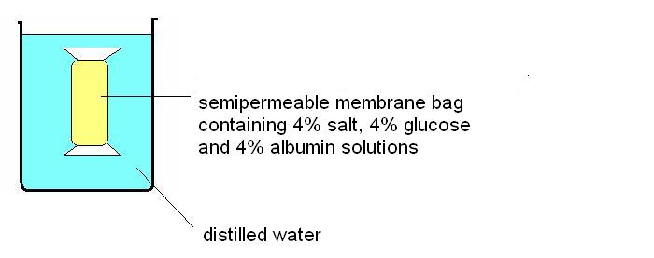
- Circle the correct answer in the statements below. (Note that salt is quite a small molecule, glucose has a moderate sized molecule and albumin is a protein and a very large sized molecule.)
  - The salt: moves into the bag / moves out of the bag / does not move
  - The water: moves into the bag / moves out of the bag / does not move
  - The albumin: moves into the bag / moves out of the bag / does not move
  - The glucose : moves into the bag / moves out of the bag / does not move
  - The salt moves by: diffusion / osmosis / active transport / it does not move because the molecules are too large.
  - The water moves by: diffusion / osmosis / active transport / it does not move because the molecules are too large.
  - The albumin moves by: diffusion / osmosis / active transport / it does not move because the molecules are too large.
  - The glucose moves by: diffusion / osmosis / active transport / it does not move because the molecules are too large.

- Suppose that a cell membrane is permeable to water but impermeable to glucose (sugar). The inside of the cell is hypertonic for glucose, in comparison to the external environment. Using the diagram below, (1) draw what the concentrations of water and glucose would look like at the beginning of the experiment (NOTE the symbols for each molecule shown below), and (2) indicate the direction of movement that would occur during osmosis. Which molecule would move?
Outside environment

• = water
Δ = glucose
Inside cell

- What are three examples of molecules that a cell would want to be able to move effectively across its cell membrane? (Be more specific than “food.”)

- What general type of organic molecule is a phospholipid? What is an example of this general type of molecule that you could find at home (in your kitchen maybe??).

- Use arrows to indicate the direction of diffusion in each case: is a molecule that can pass through the cell membrane. is a cell membrane.

A) B)

- For each of the situations below use an arrow to indicate the net movement of sugar into or out of the cell. (Assume that the sugar molecules can pass through the cell membrane in each case.)

1% sugar
5% sugar
3% sugar
1% sugar
1% sugar
1% sugar

- When you take a bath, the cells in the skin of your fingers are immersed in water.
  - Which is the stronger solution (more solute): the solution inside your skin cells or the bath water?
  - Your skin cells have a semi-permeable membrane. Does osmosis cause water to pass from the cells in your fingers into the bath, or from the bath into the cells in your finger?
  - What will happen to the size of the skin cells in your fingers?
- Honey is a very strong solution of sugar. By contrast the cytoplasm in a bacterium cell is a much weaker solution. The cell wall of a bacterium is made up of a semi-permeable membrane.
  - Would water flow from the bacterium to the jam, or from the jam to the bacterium by osmosis?

  - Suggest a reason why microbes find it difficult to survive in honey.

Reading Guide
IV: Chapter 10 (Section 10-1, p. 241)
A. Limits to Cell Growth- Skip to Exchanging Materials.
i. What substances are moving across a cell membrane?

ii. How does surface area change relative to volume as a cell gets larger?

Lab 4-2: An Investigation of the Relationship between Diffusion and Cell Size
(Revised from Kim B. Foglia, www.ExploreBiology.com, 2010)
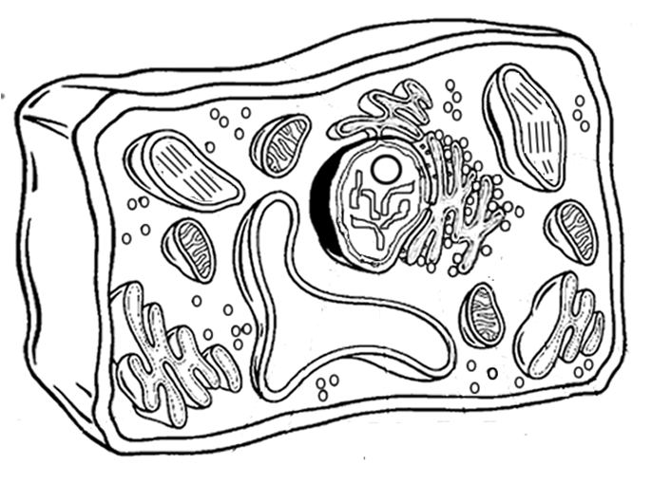
Background Information:
Most cells are between 2 micrometers and 200 micrometers – too small to be seen with the naked eye. Remember, a micrometer is 1 millionth of a meter! Why can’t cells ever become larger than that? Why don’t we regularly find one-celled organisms the size of small multicellular animals, like frogs or even flies? In other words, why can’t there ever be an organism which is visible to the naked eye and that is one giant cell? When cells grow to a certain size, their rate of growth slows down until they stop growing entirely. They have reached their limit. When one of these larger cells divides into two smaller cells, the rate of growth increases again.
In order for cells to survive, they must constantly exchange ions, gases, nutrients, and wastes with their environment. These exchanges take place at the cell’s surface – across the cell membrane. The movement of these materials is accomplished mostly by diffusion (flow of solutes from high to low concentration) across the cell membrane. Surface area is the amount of cell membrane available for diffusion. So for a cell, surface area actually represents how much diffusion can happen at one time. It would seem reasonable, then, that a cell would want plenty of surface area (meaning membrane area).
Volume is the amount of cytoplasm contained within the cell membrane. So for a cell, volume represents how long it takes to get from the membrane to the center of the cell by diffusion. Therefore, a large cell would need more materials (more metabolic need) and those materials would take longer to reach the center of the cell. What, then, is the relationship between the surface area and the volume of a cell? How does this affect the rate of diffusion of materials that pass in and out? In this lab, we will investigate this relationship and how it affects diffusion time.

Part I
In this lab activity, you will use agar cubes as cell models. You will investigate how increasing a cell’s size affects the time for diffusion to move material across the cell. The agar for the cubes has been dyed with bromothymol blue – a pH indicator that turns from blue to yellow in the presence of acid. When the agar cubes are placed in vinegar (a source of acid), they will begin to turn yellow as the vinegar diffuses into the agar. You will time this diffusion process for 3 different sized cells and compare them. Diffusion will be considered complete when the blue color completely disappears from the center of the cell.

Materials: 3 cubes of 3% agar-bromothymol blue: .5x.5x.5 cm, 1x1x1 cm, and .5x.5x4 cm (each sitting in a weight boat), timer (use your phones), 3 beakers with 100 mL of vinegar in each

Part I: Procedure:
- Complete the following steps for each of the agar cubes.
- Prepare the timer.
- Without touching the cube gently drop the cube into the beaker of vinegar
- Start the timer the moment the cube touches the vinegar
- Stop the timer when the blue color completely disappears from the center of the cube.
- Enter the time (in seconds) onto the data table on the white board
- Repeat procedure for the other two cubes
- Fill in Table 1 (page 16) with your teacher

Data Table for Part 1
Cell Size (cm) | Surface Area (units!) | Volume (units!) | SA: Volume Ratio | Time for Complete Diffusion
.5 x .5 x .5
1 x 1 x 1
.5 x .5 x 4

Part 2 Procedure
Additional Materials: one 1.5 x 1.5 X 3 agar cube, gloves, razor blade
Now that you have been able to explore the relationship between cell dimensions and diffusion time, let’s see if you can put your new-found understanding to good use. Cells come in many shapes and sizes in organisms. Natural selection favors cell shapes that enable the cell to perform its function efficiently. For example, neurons (nerve cell) and cells that line the small intestine have different jobs, so each has its own unique shape that allows it to do its job better. You will find that the relationship between structure and function is a recurrent theme throughout biology.

In this activity, each group will compete by creating cell shapes that they think will be most efficient at getting nutrients. We will then simulate natural selection by have a race to see which shape is best at its desired function. Each group will get an equal size block of bromothymol blue agar and will have the opportunity to design a cell to maximize mass but minimize diffusion time. The cell with the greatest mass and the shortest diffusion time will be judged the winner.

The Cell Diffusion Race Rules:
- No donut-like holes through the agar cell – this is biologically impossible because it is unstable.
- Once the agar cell is in the beaker of vinegar, no poking, prodding, touching the beaker.
- Teacher determines when 100% diffusion takes place. Diffusion will be considered complete when the blue color completely disappears from the center of the cell.
- Students mass agar at the end of the race and the cell must not break when handled! If the cell breaks upon massing, then the entry is disqualified.
- WINNER = highest ratio of mass divided by time.

Data Table for part 2. Cell Mass and Time for Diffusion

Circle the letter of YOUR OWN group!
Group | Sketch | Cell Mass (g) | Time for Complete Diffusion (minutes) | Mass (g) / Time (min)
A
B
C
D
E
F
G
H

Analysis Questions – Complete on a separate sheet of paper

- What evidence suggests the vinegar diffused into the 3% agar-bromothymol blue cubes?
- Copy the following chart onto your answer sheet. Complete the chart to investigate the relationship between surface area and volume as a cube increases in size.
As the cube increases in size, what happens to the surface area to volume ratio? Explain.
Cube (cm) | Surface Area | Volume | SA:V Ratio
1 x 1 x 1
2 x 2 x 2
3 x 3 x 3

- Based upon what you know about cells, explain how cells “feed” themselves. How do the nutrients get into the cell? (Don’t over-think this.)
- According to your data from Part 1, which cell was most efficient at receiving the needed “nutrient” (vinegar)? Use data from your table to back up your conclusion.
- The 1x1x1 cell and the .5x.5x4 cell have the same volume. Were their diffusion times the same? Explain why or why not.
- In general, what is the relationship between the SA:V ratio and diffusion time?
- (Honor) Most cells measure less than 0.01 cm on a side.
a. Calculate the surface area to volume ratio for a cube that measures 0.01 cm on each side. Show your work.
b. If we were able to create a 0.01 cm cube out of agar, do you think it would be more or less successful than the 1 cm cube at receiving the vinegar “nutrient?”
- In real life, provide two examples of molecules that must move into human cells?
- In real life, provide two examples of molecules that must move out of human cells?
- Describe your cell design. Explain why you chose that design – on what principles were you basing your design on to decrease diffusion time?
- (Honor) Give an example of a type of cell in a living organism (animal or plant) that is shaped very differently than the classical round or boxy shape that you see drawn in introductory textbook chapters on cells. You could pick muscle cells, cells of the small intestine, nerve cells, red blood cells, leaf pore guard cells, or some other cell. Explain how that unique shape is tied to the function that those cells can perform.

Study Sheet for Unit 4: Internal Environment - Cells
Use these questions below to help you review for the part 1 quiz
Review Questions

Journal 4-1: Can you stand the Heat?
- Define homeostasis.
- Explain how the human body, its organs, and its cells can be considered ‘compartments’.

Lab 4-1: Egg Osmosis Demo, Journal 4-2: Diffusion Demo, Notes: Transport and Diffusion and Diffusion Practice Problems
- What are diffusion, osmosis, and dialysis? Give examples of these. What causes diffusion to occur?
- Define isotonic, hypertonic, and hypotonic. Explain what happens to blood cells and onion cells when placed in isotonic, hypertonic, and hypotonic solutions. Explain why these changes occur.
- Distinguish between the following terms: permeable, impermeable, & selectively permeable.
- What is the difference among passive transport, facilitated diffusion, and active transport?
- What are the types of active transport? Know: membrane-associated pumps, endocytosis, exocytosis, phagocytosis, and pinocytosis.

Journal 4-3: Bubble Membranes
- Explain how molecular size influences whether or not a substance can pass through a membrane.
- What is the chemical make-up of the cell membrane? Explain what is meant by “lipid bilayer.”
- Why is the membrane called a fluid-mosaic model?
- Define hydrophobic and hydrophilic and apply these terms to the components of the cell membrane. What type of molecules can and cannot pass through the membrane?

Lab 4-3: Cell Size and Diffusion (Agar Cubes)
- Explain why cells MUST be small. Use the concept of surface area to volume ratio in your answer.

