**BSCS Packet #11 – Continuity - Reproduction, part 2 (Unit 6)** 2013-2014

This Activity Packet belongs to: \_\_\_\_\_\_\_\_\_\_\_\_\_\_\_\_\_\_\_\_\_\_\_\_\_\_\_\_\_\_\_

Use this packet for your classwork, class notes and homework. Work completed in the packet will be stamped (3 pts) or could be the topic of a mini-quiz (5-8 pts). Mini quizzes will occur approximately once a week and will not be announced. At the end of this learning cycle you will turn in the packet for a grade (10 pts). Several of the packet activities have sections that need to be completed on separate sheets of paper, these sections are clearly marked with a box.

|  |  |  |  |
| --- | --- | --- | --- |
| 5E Model | Packet page | Activity | Due Date |
| **Explain** | 3-5 | Journal 6-5: Formation of Gametes – Meiosis Notes |  |
| **Explain** | 6-8, 14, 18 | Notes: Organismal Reproduction (3 parts) |  |
| **Explore** | 9-13 | Journal 6-6: Hormonal Control of the Menstrual Cycle and Sperm Production |  |
| **Elaborate** | 15-16 | Journal 6-7: Biological Basis of Birth Control |  |
| **Explain** | 17 | Practice Questions – Human Reproduction |  |
| **Explore** | 19 | Lab 6-1: Plant Reproduction |  |
| **Evaluate** | 20 | Unit 6 Review Guide for Part 2 |  |

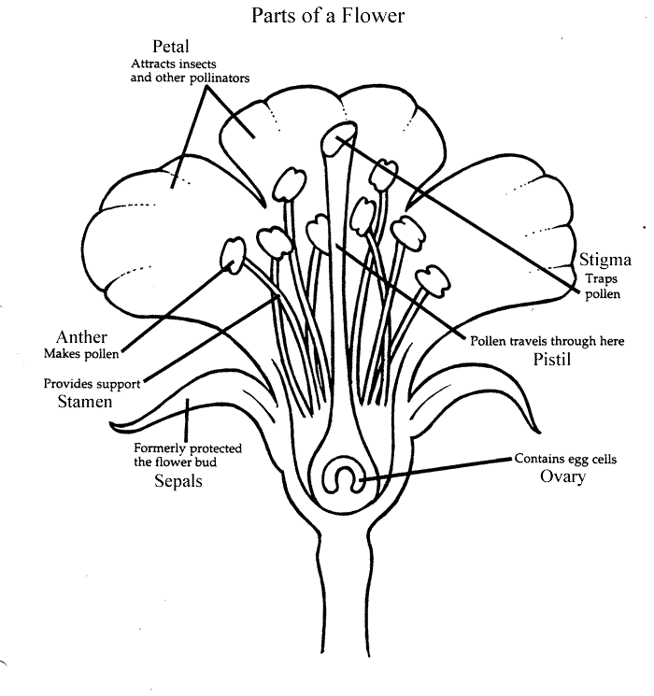

If this packet is LOST, please:

drop it off at the BHS Science Dept. (rm 365) OR

drop it off in Mr. Kozel’s classroom (360) OR

call the Science Dept. at (617) 713-5365

**Reading Guide Part I**

**Chapter 11-4 Meiosis (p. 275-278)**

I. How are genes and chromosomes related to one another?

**Chromosome Number**

1. What are homologous chromosomes? You can draw and label or describe them.

2. What is a diploid set of chromosomes? How many chromosomes are there in a diploid set for humans?

3.. What is a haploid set of chromosomes? How many chromosomes are there in a haploid human cell?

4. Why is it important that a gamete (egg or sperm) to be haploid?

5. Use Figure 11-16 to describe how sister chromatids compare and how homologous chromosomes compare.

**Phases of Meiosis**

6. Go online to Active Art by typing in PHSchool.com. Put in the code cbp-4114 and go to the Meiosis activity for practice. Answer the questions below. CLICK ON THE START BUTTON TO SEE A CELL GO THROUGH MEIOSIS.

7. What happens to the number of chromosomes per cell during meiosis?

8. Briefly describe what happens during interphase.

9. • Place the following stages of meiosis I in the correct order.

\_\_\_\_\_ telophase I and cytokinesis

\_\_\_\_\_ prophase I

\_\_\_\_\_ anaphase I

\_\_\_\_\_ metaphase I

10• What is the end result of meiosis II?

**Journal 6-5: Formation of Gametes (Meiosis)**

**Introduction:** Gametes are necessary for sexual reproduction. The process that starts the formation of a gamete is called meiosis. Meiosis is a special type of cell division that occurs in the testes and in the ovaries. In this activity you will learn about the process that forms sperm and ova and view an animation of the meiosis process.

**Process and Procedures**

1. Take notes on meiosis, spermatogenesis, and oogenesis.

|  |
| --- |
| **meiosis-bigMeiosis** |
| **human_karyotypeChromosomes in Humans** |
| **Tetrads/Homologous Chromosomes** |
| **Meiosis I**  **meiosis-big** |
| **meiosis-bigMeiosis 2** |
| **CDA45_1Spermatogenesis** |
| **Oogenesis** |

Web Activity – Answer the analysis questions as you watch the videos.

1. First, go to the website [**http://www.biostudio.com/d\_%20Meiosis.htm**](http://www.biostudio.com/d_%20Meiosis.htm) and watch the narrated version of this animation. (If you have headphones, they will come in handy here…)
2. Next, open a new tab and go to the website

[**http://highered.mcgraw-hill.com/sites/0072495855/student\_view0/chapter28/animation\_\_how\_meiosis\_works.html**](http://highered.mcgraw-hill.com/sites/0072495855/student_view0/chapter28/animation__how_meiosis_works.html)Watch the video on this website (again, using your headphones). You can pause and rewatch sections if you need to while filling out the analysis questions

**Journal 6-5: Analysis Questions (complete on a separate sheet of paper)**

1. What is a tetrad?
2. How many tetrads are present in Prophase I in these animations?
3. Describe “crossing over”. How could this lead to more variation in a species?
4. How do these animations show that crossing over has taken place?
5. In what phase do the tetrads split apart and move to opposite ends of the cell?
6. At the end of Telophase I, the daughter cells are haploid. Explain why this is true.
7. In which phase do the sister chromatids split and move to opposite ends of the cell?
8. Find Telophase II in the McGraw Hill animation (2nd website). Look closely at the chromosomes in the forming nuclei of new gametes. Are the gametes genetically different? How does this contribute to variation in a species?

# What are 2 differences and 2 similarities between mitosis and meiosis? You may need to refer back to your notes on mitosis to answer this question. You could also watch the animation at <http://www.biostudio.com/d_%20Mitosis.htm> for help PRACTICE: Comparing Mitosis vs. Meiosis

|  |  |  |
| --- | --- | --- |
|  | MITOSIS | MEIOSIS |
| Why does it happen? |  |  |
| Where does it happen? |  |  |
| How many rounds of cell division? |  |  |
| How many products? |  |  |
| Are the products diploid or haploid? |  |  |
| How does mitosis compare with meiosis I? |  |  |
| How does mitosis compare with meiosis II? |  |  |

**Reading Guide Part II**

**The Endocrine System Chapter 39-1 (p. 997)**

I. What is the Endocrine System?

Hormones

I. Describe generally how a hormone works. Be sure to include what a target cell is.

II. Using Figure 39-2 list the 4 glands that are directly involved in reproduction. Make sure you include the two glands that stimulate puberty since they are involved on a regular basis in producing gametes.

**Notes: Organismal Reproduction – Part 1: Human Anatomy**

|  |
| --- |
| **Human Reproductive Strategy** |
| FEMALE ANATOMY:   |  |  | | --- | --- | | **NAME OF STRUCTURE** | **DESCRIPTION** | | OVARIES | Follicle  Corpus Luteum | | OVIDUCT/FALLAPIAN TUBE | Fimbriae | | UTERUS | Endometrium | | CERVIX |  | | VAGINA |  | |

**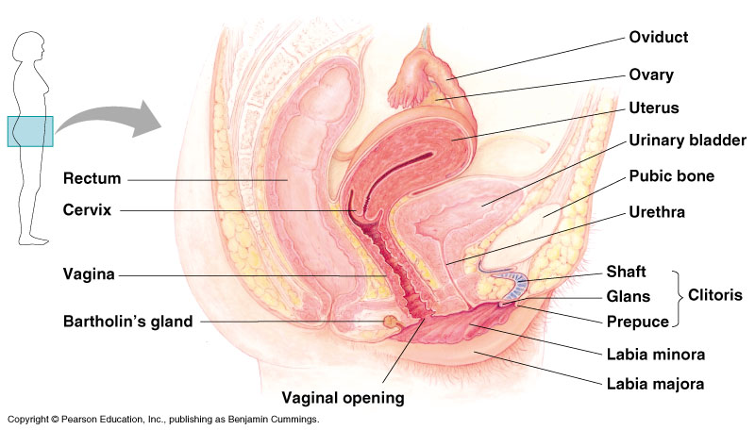**

**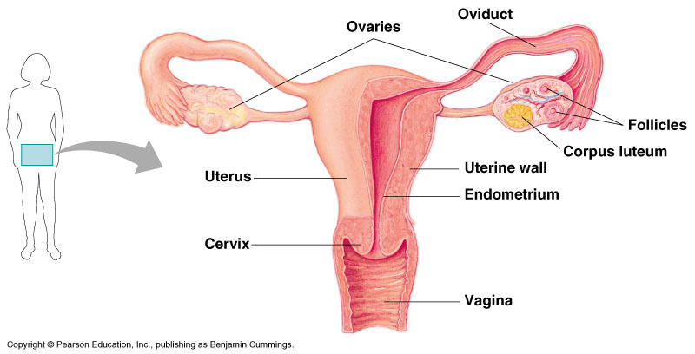**

MALE ANATOMY

|  |  |
| --- | --- |
| **NAME OF STRUCTURE** | **DESCRIPTION** |
| TESTES | Seminiferous tubule |
| EPIDIDYMIS |  |
| SCROTUM |  |
| VAS DEFERENS |  |
| PROSTATE GLAND |  |
| SEMINAL VESICLE |  |
| BULBURETHRAL GLAND (COWPER’S GLAND) |  |
| URETHRA |  |

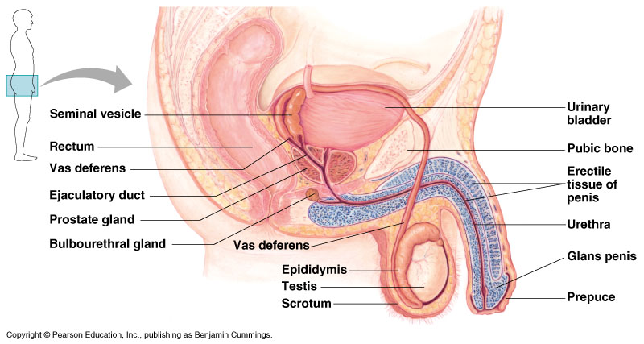

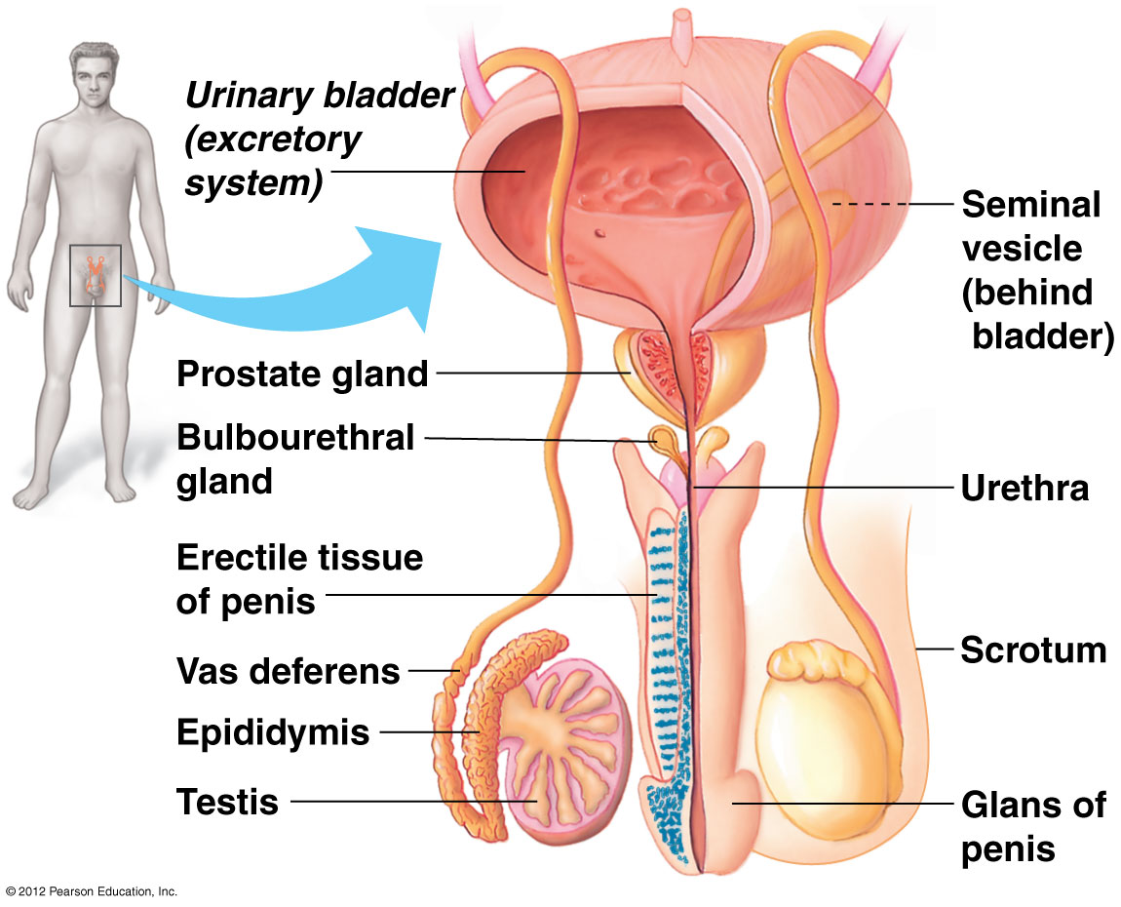

J**ournal 6-6: Hormonal Control of the Menstrual Cycle and Sperm Production**

**Introduction:** In this activity you will be introduced to the endocrine system and learn its role in regulating the reproductive cycles in humans.

**Process and Procedures**

1. Listen to an introduction of the endocrine system and take notes in the space provided.

|  |
| --- |
| **Endocrine System** |
| **Hormones**  **hormone** |
| **HypothalamusHypothalamus** |
| **Pituitary Gland**  **4005b** |

**Hormones and Sexual Reproduction**

BSCS Biology: A Human Approach, 3rd edition, p481-484

For human females and males, the joining of ova and sperm is highly regulated. Hormones are molecules that regulate the reproductive system during development and after sexual maturity. This regulation mainly involves communication between endocrine glands in the brain and the reproductive organs.

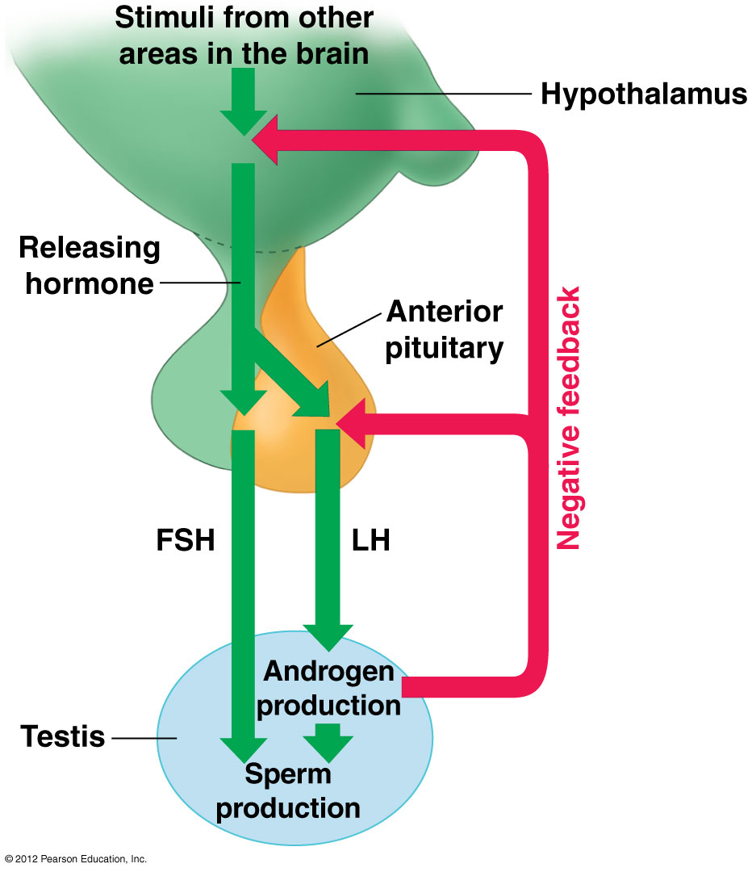 Changes in certain hormonal levels control the onset of puberty. There are many external indicators of sexual maturity. Body proportions change. Underarm and pubic hair grows. An interest in sex begins. Vocal cords lengthen and the voice deepens, especially in males. Facial hair grows.

In addition to those external indicators, there are internal indicators of sexual maturity. In both males and females, the hypothalamus directs the anterior pituitary to release **follicle stimulating hormone (FSH)** and **luteinizing hormone (LH)**. In males, FSH stimulated the testes to produce sperm. LH stimulates the release of the major male sex hormone, **testosterone**, from the testes (see Figure E10.7). In females, FSH and LH are involved in regulating ovulation.

After maturity, hormones continue to signal the events that lead to the production of gametes and that promote sexual behavior. In a mature male, testosterone stimulates continuous sperm production. Erection of the penis and ejaculation depend on sufficient levels of testosterone in the bloodstream. As shown in Figure E10.7, negative feedback loops between the testes, the hypothalamus, and the anterior pituitary reduce the level of LH and FSH. When the level of testosterone in the blood rises too high, the hypothalamus signals the anterior pituitary to release less LH. Less LH translates into less testosterone released from the testes.

In females, hormonal interactions are similar, but more complex. The ovaries produce the major female sex hormones. These are **estrogen** and **progesterone**. After puberty, these hormones regulate reproductive function. In contrast to sperm, which are produced continually, ova mature and are released from the ovaries as part of the a monthly cycle. The **menstrual cycle** is depicted in Figure E10.8. FSH signals an ovum to mature inside a sac, or follicle, on the surface of one ovary. The maturing follicle releases estrogen. Estrogen stimulates the secretion of LH. The dramatic rise of LH stimulates ovulation. During **ovulation**, the mature ovum bursts out of the follicle. Ovulation occurs around the middle of the cycle. The entire cycle lasts about 28 days, although it may range from 24 days to more than 35 days.

Estrogen and progesterone also prepare the uterus for a possible pregnancy. During the first half of the cycle, the level of estrogen increases. Estrogen stimulates the inner lining of the uterus to thicken with increased blood vessels. If sperm enter the vagina anytime between the few days before ovulation to a day or so afterward, a sperm and ovum may join. Pregnancy will occur if the resulting embryo implants in the uterus.

An ovum can be fertilized only during a 10- to 15-hour interval after ovulation. Sperm, however, can survive up to 72 hours. This means that sexual intercourse several days before ovulation still may result in pregnancy. Because individual menstrual cycles vary so much, it is extremely difficult to predict exactly when a female will ovulate. Because the timing of ovulation is not predictable, pregnancy can occur if sexually active individuals do not use birth control. No birth control measure (except abstinence) is 100 percent effective. Pregnancy can occur even when these preventative measure are used.

During the second half of the menstrual cycle, the level of progesterone increases (see Figure E10.8). After the ovum leaves the follicle, the follicle reorganizes into a structure call the corpus luteum. The **corpus luteum** secretes progesterone. Progesterone is the hormone responsible for maintaining the thickened, blood-rich inner lining of the uterus. The corpus luteum disintegrates after about 12 days, unless pregnancy occurs. If an embryo implants in the lining of the uterus, a placenta develops from embryonic and maternal tissue. The placenta nourishes the growing embryo. It also secretes progesterone. Progesterone helps maintain the lining of the uterus.

If fertilization does not occur, hormone levels drop. The lowered hormone levels decrease the blood supply to the inner lining of the uterus. Part of the lining then disintegrates and passes from the uterus through the vagina and out of the body. The shedding of the lining is called **menstruation**. During menstruation, a small amount of blood is expelled (between 50 mL and 150 mL – about ¼ cup to a little more than ½ cup). Menstruation begins on day 1 of the cycle.

In humans, fertility declines with age. For females, just as menstruation marks the beginning of sexual maturity, **menopause** marks the end. At menopause, females no longer have a menstrual cycle and no longer ovulate. The effects and timing of menopause vary widely. Menopause usually takes place between the ages of 45 and 50.

For males, sperm production continues. The number and health of their sperm cells, however, may decline as they ages. If enough healthy sperm are produced, a male of advanced age is still capable of impregnating a female.

1. Use the reading *Hormones and Sexual Reproduction* on pages 10 and 11 of the packet to help you with the following questions about the male reproductive cycle.
   1. In males, gametes form in the endocrine organ called the testes. The male gamete is the sperm. Hormones released from the pituitary gland control the rate at which sperm are produced. Which hormone produced by the pituitary controls the production of sperm?
   2. The major male sex hormone is testosterone. How is the release of testosterone regulated?
   3. What is the function of testosterone in sexual reproduction?
   4. What do high levels of the hormone testosterone cause the pituitary gland to do?
   5. How do you think the pituitary gland would respond to stimuli collected from the environment that induce sexual arousal?
2. Use the reading *Hormones and Sexual Reproduction* on pages 10 and 11 of the packet to help you with the following questions about the female reproductive cycle.
   1. What are the hormones produced by the pituitary gland that control the female reproductive cycle?
   2. What hormones do the ovaries produce?
   3. HONOR ONLY: In females, gametes are produced in the ovaries. The female gametes are called ova (sing. ovum) and are present in females at birth. In females, hormonal interactions are similar to males, but more complex. Hormonal levels are on monthly cycle called the menstrual cycle. Use the data below to make a graph of hormone levels during the menstrual cycle. An average menstrual cycle lasts 28 days, though the length of the cycle varies considerably from female to female, and from month to month. Below, you can see blood levels of four different hormones: Luteinizing Hormone (LH), Follicle Stimulating Hormone (FSH), Estrogen, and Progesterone. As you can see, the level of each of these hormones changes over the course of the menstrual cycle. First, answer the following questions to get acquainted with the data:
      1. On what day does LH peak? \_\_\_\_\_\_
      2. On what day does estrogen start to rise? \_\_\_\_\_\_
      3. On day 27, which hormone is most plentiful in the blood? \_\_\_\_\_\_
      4. If you were to create a line graph, what would be your dependent variable? \_\_\_\_\_\_\_\_\_\_\_\_\_\_\_\_\_\_
      5. If you were to create a line graph, what would be your independent variable? \_\_\_\_\_\_\_\_\_\_\_\_\_\_\_\_\_
      6. Sketch the design of your line graph below (label each axis, but do not plot the data)

**Journal 6-6: Analysis Questions (complete on a separate sheet of paper) -** use your textbook, and/or any class notes and figure the Menstrual Cycle Figure on pg. to when answering the questions.

1. What are the four hormones involved in the menstrual cycle?

2. Look closely at the menstrual cycle figure. What patterns do you notice?

3. What is the endometrium (uterine) lining? What is the purpose of a thickened lining?

4. What is menstruation?

5. What is ovulation? On what (approximate) day does ovulation take place?

6. What is the difference between the ovary and the corpus luteum?

7. What is the pituitary gland; where is it found; and what role does it play in the female menstrual cycle?

8. What patterns do you notice, when comparing endometrium thickness to hormonal levels? (Look at each hormone individually and make observations only! It is OK to say there is no pattern. Example – “Always, as \_\_\_\_\_ rises, the lining gets thicker.”)

* 1. A change in which hormone(s) level causes the lining to thicken (or to stay thick)? (Use your evidence from question b to answer this question) Is it a decrease or an increase?
  2. A change in which hormone(s) causes menstruation? Is it a decrease or an increase?
  3. What do you think happens to each of the four hormone levels when a woman becomes pregnant? (Note: When a woman is pregnant, she usually does not menstruate.)
  4. 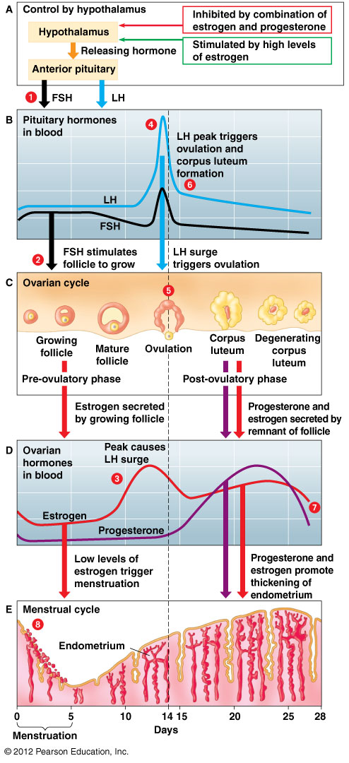What patterns do you notice, when comparing events in the ovary to hormonal levels? (Look at each hormone individually and make observations only! It’s OK to say there is no pattern.)
  5. A significant change in which hormone(s) do you think causes ovulation? Is it a decrease or an increase?
  6. Imagine that LH didn’t peak, and stayed at relatively low levels throughout the menstrual cycle. How would this affect the cycle?

9. Honor: You are a fertility specialist, and a woman comes to you for help. She has been trying to become pregnant for two years and has been unsuccessful. Provide a hypothesis relating to **hormonal** levels that could explain why she has been unsuccessful.

**Menstrual Cycle Figure**

**Notes: Organismal Reproduction – Part 2: Hormonal control**

|  |
| --- |
| Hormonal Control of sperm production |

MALE:

|  |  |  |
| --- | --- | --- |
| NAME OF HORMONE | WHAT PART OF THE BODY PRODUCES THIS HORMONE | THE EFFECT OF THIS HORMONE |
| Luteinizing Hormone (LH) |  |  |
| Follicle Stimulating Hormone (FSH) |  |  |
| Testosterone |  |  |

|  |
| --- |
| Hormonal control of Female Reproductive Cycles |

FEMALE:

|  |  |  |  |
| --- | --- | --- | --- |
| NAME OF HORMONE | WHAT PART OF THE BODY PRODUCES THE HORMONE | THE EFFECT OF THIS HORMONE | |
| Luteinizing Hormone (LH) |  |  | |
| Follicle Stimulating Hormone (FSH) |  |  | |
| Estrogen |  |  | Combined function |
| Progesterone |  |  |

**Journal 6-7: The Biological Basis of Birth Control**

Study the descriptions of the 13 methods of birth control that are given on the handout "Birth Control Comparison Chart” (on the next page of the packet). Use your textbook, the readings in this packet on page 10-11 and the table on the next page.

Procedure:

1. Sort the 15 methods of birth control into 3 different categories: Physical barriers, chemical methods, and behavioral methods.
2. After they have been sorted, list them in the appropriate space in the chart below.
3. Fill in the remaining columns of the table.

|  |  |  |  |
| --- | --- | --- | --- |
|  | Device | Brief Description | Failure Rate  (STDs and pregnancy) |
| Physical Barriers |  |  |  |
| Chemical Methods |  |  |  |
| Behavioral Methods |  |  |  |

**Birth Control Method Comparison Chart**

|  |  |  |  |
| --- | --- | --- | --- |
| **Device/method** | **Description** | **Failure rate\* (pregnancies per 100 women per year)** | **Protection against STIs/STDs?** |
| Abstinence | Abstaining from sexual contact. (Completely prevents sexual transmission of AIDS.) | 0 | Yes |
| Cervical Cap | Small, dome-shaped rubber cap that is inserted through the vagina to closely cover the opening entrance to uterus (cervix). | 22.0  (if spermicide is not used)\*\*\* | No |
| Male Condom | Thin sheath made of latex or animal skin that is placed over the penis. Often coated with spermicide. *Only latex* will help protect against AIDS.\*\* | 7.3  (if spermicide is not used)\*\*\* | Yes |
| Female Condom | A plastic pouch inserted into the vagina before sexual intercourse. There is a ring at the open end to keep it outside of the vaginal opening. | 15  (if spermicide is not used)\*\*\* | Yes (less than male condoms) |
| Diaphragm | Flexible wire circle covered with latex that is placed over entrance to uterus (cervix). Generally used with spermicide. | 10.0  (if spermicide is not used)\*\*\* | No |
| Injectable progesterone-like substance | An injection for females that lasts up to 3 months. May cause menstrual irregularities. | 1.0 | No |
| Implant devices | Capsules containing synthetic progesterone that are inserted surgically under a female’s skin. They slowly release hormones for 3-5 years. | 1.0 | No |
| Intrauterine device (IUD) | Small plastic or copper device placed (by a physician) inside the uterus. Effective for 10 years. Probably causes mild inflammation of uterine wall. | 1.0 | No |
| Natural family planning (rhythm method) | Systematic monitoring and recording of data to determine time of ovulation. Then abstaining from sexual intercourse for several days around the time of ovulation. | 26.0 | No |
| Oral contraceptives (birth control pills) | Synthetic estrogen and synthetic progesterone (or progesterone only) that a female takes in tablet form throughout menstrual cycle. | 0.3 | No |
| Spermicide | Foam, cream, jelly, or suppository preparations that contain chemicals that kill sperm. Spermicides are place in the vagina prior to sexual activity. | 15.0 (if used alone) | No |
| Ortho Evra Patch | A thin, plastic patch that sticks to the skin and releases synthetic estrogen and synthetic progesterone. | 0.3 | No |
| Vaginal Contraceptive Ring (NuvaRing) | A small, flexible ring that a woman inserts into her vagina once a month and releases synthetic estrogen and synthetic progesterone. | 0.3 | No |
| Tubal ligation (sterilization) | Oviducts in female are surgically severed and tied off | 0.5 | No |
| Vasectomy (sterilization) | Vas deferens in male is surgically severed and tied off | 0.6 | No |

\*Failure rate can be *much* higher if method is not used properly. For example, if condom is used *after* sexual intercourse has begun, some sperm already may have been released.

\*\* Natural membrane condoms, as compared with latex condoms, have larger micropores. These condoms may permit passage of pathogens such as HIV.

\*\*\*Combined use of spermicide with condom or diaphragm is more effective than either of these methods used alone.

**Human Reproduction Practice Questions**

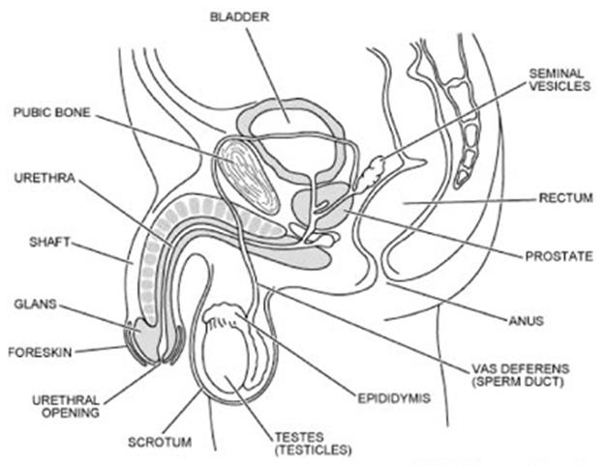

F

E

D

C

B

A

A

B

C

D

E

F

G

H

Questions 1-5 refer to the diagrams.

1. Eggs are produced by the structure labeled with the letter \_\_\_\_\_\_. This structure is called the \_\_\_\_\_\_\_\_. When an egg is ovulated, it moves into the structure with the letter \_\_\_\_\_. This structure is called the \_\_\_\_\_\_\_\_\_\_.
2. Pregnancy occurs in the structure labeled with the letter \_\_\_\_\_\_. This structure is called the \_\_\_\_\_\_\_\_\_\_, and its lining is called the \_\_\_\_\_\_\_\_\_\_\_\_\_\_\_\_\_\_\_\_\_\_. The (usually monthly) shedding of the lining is called \_\_\_\_\_\_\_\_\_\_\_\_\_\_\_\_\_\_.
3. If the structure labeled with the letter \_\_\_\_\_ did not exist, sperm wouldn’t be produced properly because the temperature would be too \_\_\_\_\_\_\_. This structure is called the \_\_\_\_\_\_\_\_\_.
4. The structure with the letter \_\_\_\_ is responsible for adding sugar to the semen.
5. If the structure with the letter \_\_\_\_ were damaged, the sperm in the semen would be more likely to be damaged by the acidity of the vagina. This structure is called the \_\_\_\_\_\_\_\_\_.
6. You overhear the following conversation between Victoria and Josephine.

Victoria: “Don’t worry about it. Unless you have sexual intercourse with him on the same day you ovulate, you definitely won’t get pregnant.”

Josesphine: “Really? I thought that there was a chance of pregnancy anytime.”

What do you think? Explain your answer.

**Notes: Organismal Reproduction – Part 3: Flowering Plants**

|  |
| --- |
| Anatomy of a Flower  flower parts good pic.jpg |
| Pollination  . |
| What is double fertilization? |
| Seeds and Fruits |

**Lab 6-1: Flower Reproduction**

**Introduction:** The shapes and colors of flowers catch our attention and we may wonder why they are so attractive and varied in form. By observing blooming plants, scientists have discovered complex relationships between flowers and their environment. Those plants that depend on the moments of animals for pollination often show adaptations that attract specific animals. The colors, designs, and scents are specific to the sensory range of the pollinator. Even the shape of the flower (such as a snapdragon) may fit its pollinator perfectly, while blocking the entry of other animals.

The pollinator also has adaptations that are specific to flowers it visits so that the pollen is successfully transferred from the pollinator to the stigma. How does successful pollination benefit the pollinator? The transfer of pollen between plants of the same species is the initial step in the process of creating seeds. The structures and behaviors of the pollinator inadvertently increase the pollinator’s food supply over time. In this way, successive generations of plants and their pollinators become increasingly dependent on each other.

In this lab, you will study the structure of a flowers and seeds as it is related to pollination and fertilization. **Write ALL answers on your separate lab sheet.**

**Part A. Flower Dissection**

1. Obtain a flower for your pair/ group to investigate.
2. Record the name of the flower/plant.
3. Remove 2 or 3 petals from one side of the flower. Now you will do a quick series of sketches on a separate paper – follow your teacher’s directions.
4. On the final sketch, label the structures that you have drawn.
5. Note that some plants have only one gender – male or female. The flowers we are looking at will have both male and female sexual structures. What benefits and what drawbacks might having BOTH sex structures in one flower create? List at least one of each.
6. Remove the rest of the petals, if any. Identify and remove the male structures – observe where the pollen is held. Why do you think the pollen is held on top of the long filament?
7. The female structure should remain. Now, take a razor and carefully slice open the **pistil** as shown in the diagram below.

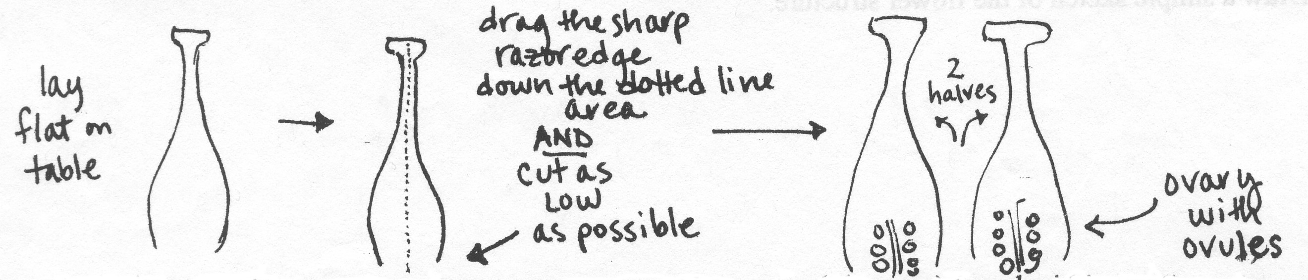

1. Using a hand lens or dissecting microscope, try to see the ovules (like eggs) found inside the flower’s ovary. Estimate how many ovules you see in both halves of the ovary.

NOTE: The white stacked disks are ovules. Each ovule is one female gamete, the equivalent of an unfertilized egg in an animal. After fertilization by a pollen grain, each ovule will form a seed.

**Part B. Seed Dissection**

1. Look carefully at the **dry** pinto or kidney bean. Examine it with a hand lens. Sketch and describe what you see.
2. Use the hand lens to observe the soaked pinto or kidney bean. Compare it to the dry bean. What differences do you see?
3. Carefully remove the outside covering of the **soaked** pinto or kidney bean and gently pull apart the two halves of the seed. Examine each half with the hand lens. What do you see inside the seed? Label the *seed coat, endosperm* (food supply)*,* and *embryo* on your drawing.

**Study Sheet for Unit 6: Continuity - Reproduction**

**Review Questions**

1. What is the difference between sexual and asexual reproduction?
2. What are some of the changes in reproductive strategies that evolved as organisms became more complex?
3. Describe some of the diverse reproductive strategies found in plants, animals, fungi, protists, and bacteria.
4. Why is it best to describe mitosis as a process of duplication and division rather than just a simple cell division?
5. What are the stages in mitosis, and what happens in each stage? Be able to recognize each stage on a diagram – provide an unlabeled diagram of each stage and hand-label it.
6. What are the differences between mitosis of plant and animal cells?
7. Use the process of mitosis to explain: how a cut heals? How a cancerous tumor develops? How planaria regenerate new parts?
8. What are chromosomes? Why are they necessary for the continued existence of cells?
9. What is the science behind cloning? Describe the bioethical concerns about this topic.
10. What are causes and treatments of cancer?
11. What are the structures and functions of the female anatomy? (Know ovaries, oviduct/ Fallopian tube, uterus, cervix, and vagina.) Be able to identify these on a diagram.
12. Trace the path of the egg from where it is made in the ovary to where it is fertilized and if it is fertilized, where it develops in the female. If it is not fertilized, what will be the result?
13. What are the structures and functions of the male anatomy? (Know scrotum, testes, epididymis, vas deferens, bulbourethral/ Cowper’s gland, seminal vesicle, prostate, urethra, and penis.) Be able to identify these on a diagram – provide a diagram and hand-label these parts.
14. Why are the testes of the human male located outside the body?
15. Trace the path of a sperm from where it is made in the testes through the various parts of the male reproductive system until it exits the body.
16. What do the prostate gland, seminal vesicle, and bulbourethral (Cowper’s) gland add to the semen? How does this help the sperm in its journey to the egg?
17. Generally, how do hormones regulate the menstrual and ovarian cycles in the human female? How are these two cycles linked?
18. What are the functions of the following hormones: luteinizing hormone, follicle stimulating hormone, estrogen, progesterone, testosterone, gonadotropin-releasing hormone?
19. What organs or structures secrete the above hormones?
20. Which hormone(s) is/are responsible for causing ovulation?
21. A decrease in which two hormones cause menstruation?
22. How do behavioral, physical, and chemical forms of birth control work? Explain the difference between these three types and give two examples of each type.
23. What is the difference between oogenesis and spermatogenesis? What is the significance of this difference?
24. What are some of the changes that occur in the fertilized human egg as it develops from a zygote to an embryo to a fetus?
25. What do the ectoderm, mesoderm, and endoderm eventually become in the offspring?
26. How do flowering plants reproduce? What are the parts and functions of the flower? What does the ovary become? The fertilized ovule?
27. What is the difference between pollination and fertilization? Explain what double fertilization is in angiosperms (flowering plants). What is an endosperm?