Name: ______________________________ Date: ______________ Block: ______________
Journal 3-5: Digestive System
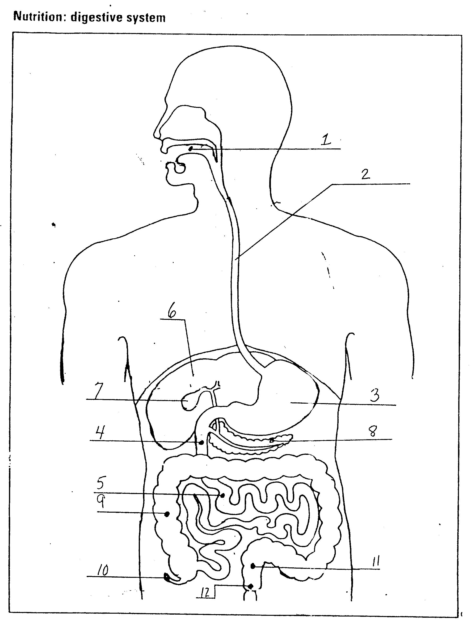

Procedure:
- Day 1: Take notes using pg 978-984 in the text book and classnotes on the human digestive system in the chart on the next 2 pages.
- Day 2: Using the PowerPoint slides provided by your teacher, put the organs in the order that food arrives at them in the digestive tract. The sequence given to you is NOT the correct order (that would be too easy…). Your job is to provide details about a monosaccharide’s journey from mouth to bloodstream. You need to complete the blanks (you can change the words, of course) AND put the slides in order such that the story makes sense. Use your notes on the next page and pages 978-984 of the textbook to help you.

HUMAN DIGESTIVE SYSTEM NOTES

What are three primary functions of the human digestive system? (HINT: think nutrients and waste)

___________________________________________

___________________________________________

___________________________________________

Location in Body | Part of digestive tract? | Key Terms | What happens here?
Mouth |  | amylase, saliva, teeth, tongue, mechanical digestion, chemical digestion
Esophagus |  | peristalsis
Stomach |  | muscles, mechanical digestion, pepsin, chyme
Small Intestine |  | villi, duodenum, bile, enzymes, chemical digestion
Location in Body | Part of digestive tract? | Key Terms | What happens here?
Pancreas |  | enzymes
Liver |  | bile
Gall Bladder |  | bile
Large Intestine (Colon) |  | rectum, anus, bacteria

Digestion Review

Using the following diagrams and the work you did on the previous page, mark with an M where that nutrient will be mechanically digested (and in parentheses write which kind of mechanical digestion occurs there – chewing, peristalsis, churning, emulsification) and with an C where that nutrient will be chemically digested (and in parentheses write the enzyme(s) that work there).

Carbohydrates Proteins Lipids

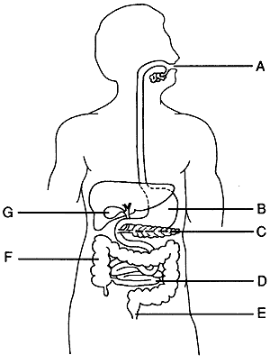
Analysis Questions

Be sure to turn in powerpoint slides from step 2. Staple them in order.

- Why is digestion necessary?
- What is the chemical reaction of digestion is called (dehydration synthesis or degradation hydrolysis)?
- Why is it preferable to break food items into smaller pieces?
- What is digested in the mouth?
- What is digested in the stomach? Describe what conditions are like in the stomach. What is the name of the contents of the stomach?
- What is made in the liver and stored in the gallbladder? What does this substance do?
- The pancreas is important in the digestive system. Why?.
- What is the name of the structures on the surface of the small intestine? What is the role of the structures named?

