Activity: Visualizing Cells - Use the following websites to explore the organelles that you have been learning about.
http://www.cellsalive.com/cells/cell_model.htm and/or http://learn.genetics.utah.edu/content/cells/insideacell/

E (dot)

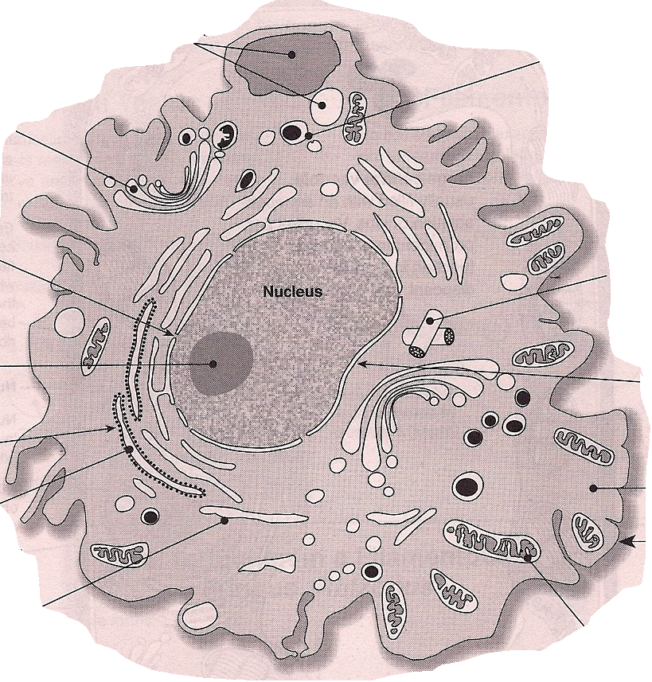
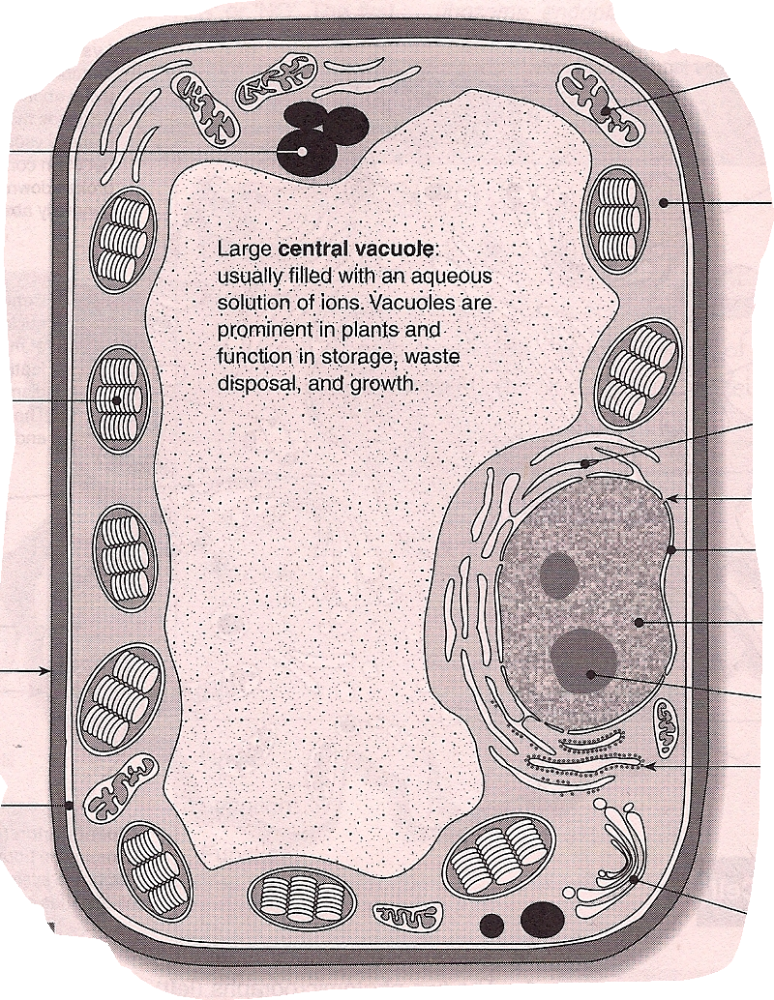
A
L
M
B
Starch granules stored within amyloplasts
K
L
C
J
A
I
K
D
H
G
J
E
B
F
F
I
C
G
D
H

A = ____________ G = ____________ A = ____________ G = ____________
B = ____________ H = ____________ B = ____________ H = ____________
C = ____________ I = ____________ C = ____________ I = ____________
D = ____________ J = ____________ D = ____________ J = ____________
E = ____________ K = ____________ E = ____________ K = ____________
F = ____________ L = ____________
M = ____________

Name of Organelle or Cellular Feature | Description of  Function | Description of  Structure | Diagram | In all Eukaryotic cells? If not, in which specific types? | In Prokaryotic cells? | Other information | Analogy
Cell Membrane | To allow molecules into and out of the cell | Phospholipid bilayer with protein “tunnels” embedded in the bilayer |  | yes | yes | Cholesterol in the membrane and carbs are on outside | Customs officer for a country; gate keeper
Nucleus

Ribosomes

Mitochondria

Rough Endoplasmic Reticulum

Smooth Endoplasmic Reticulum

Name of Organelle or Cellular Feature | Description of  Function | Description of  Structure | Diagram | In all Eukaryotic cells? If not, in which specific types? | In Prokaryotic cells? | Other information | Analogy
Golgi
Apparatus

Lysosome

Chloroplast

Central Vacuole

Cell Wall

Cytoskeleton

Place each of the following into the Venn Diagram: cell membrane, cell wall, smooth ER, rough ER, ribosomes, golgi apparatus, lysosome, large central vacuole, , nucleus, DNA, cytoplasm, chloroplast, mitochondria, eukaryotic

Plant cells
Animal cells
Prokaryotic cells

